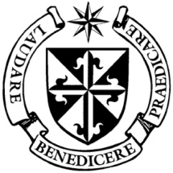
Dominican Newsletter
St. Catherine’s Church, Dominic Street, Newry.
22nd March 2026 Tel: Tel: 028 3026 2178 5th Sunday of Lent
Masses: Vigil: Sat 7.30pm, Sunday: 8.00am, 9.30am, 11.00am, 12.30pm.
Weekdays: 7.30am, 11.00 am, 7.30 pm ( incl. Vigil Sat.)
Confession: Saturday: 11.30am - 12.30pm and 4.00pm – 5.00pm
Website: https://newrydominican.com/ Facebook: www.fb.com/newrydominican
Watch live: newrydominican.com/live Lectio Centre: lectio.newrydominican.com

TAKE THE STONE AWAY!
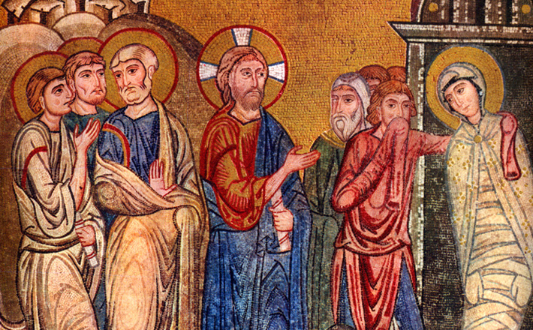

Jesus brings Lazarus back to life

Martha, Mary and Lazarus were close friends of Jesus and he was always welcome in their home. They were an ordinary family where Jesus felt relaxed. They knew Jesus well.
When Lazarus died, Jesus cried showing how close he was to Lazarus. Martha and Mary discuss the death of Lazarus with Jesus.
Jesus is impressed with their faith and with a sigh from the heart brings Lazarus back to life.

‘So they took away the stone.
Then Jesus lifted up his eyes and said:
‘Father, I thank you for hearing my prayer. I knew indeed that you always hear me, but I speak for the sake of all these who stand round me, so that they may believe it was you who sent me.’

Church Restoration Fund
Country Music
Cabaret Night
Next Thursday 26th March
8.00pm
Gavin Gribben Band
Hugo Duncan
Leon, Ennis Brothers
Kevin Kearney

Canal Court Hotel

Tickets £25 (available at
Lectio Centre & Canal Court Hotel)

MC: Kevin McAllister

The Annunciation of the Lord
Wednesday 25th March

‘Hail Mary, full of grace, the Lord is with thee, Blessed art thou among women and blessed is the fruit of thy womb Jesus’

Next Sunday is PALM SUNDAY

CLOCKS GO FORWARD
next weekend.




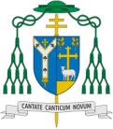
Easter Mass Bouquets
Easter Mass Bouquets are now available in the Lectio Office.
The intentions will be remembered in the Masses and Prayers over the Octave of Easter.

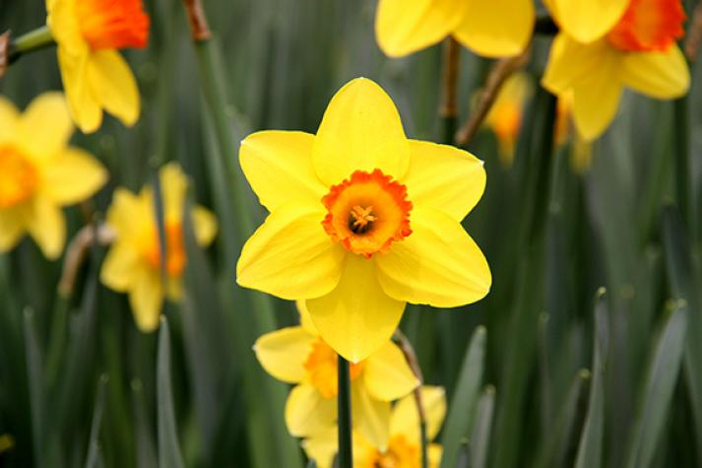

Holy Thursday Chrism Mass
Archbishop Eamon Martin, along with the clergy of the Diocese, will celebrate the Chrism Mass on Thursday 2nd April 2026 at 10.30 a.m. Mass in the Cathedral of St. Patrick & St. Colman, Newry.
All are welcome.
In particular, an invitation to attend is extended to families and schools in the Diocese with children who will make their Confirmation this year.
The Mass is also available
via Newry Parish webcam at churchmedia.tv/Newry Cathedral

EASTER RAFFLE (Spy Wednesday)
£5 a line for the Draw
Now in the Lectio Office.

Lots of Great Prizes to be won!
Proceeds go towards supporting Church, Priory and Lectio Centre.

HOLY WEEK 2026
Palm Sunday
Palms will be blessed and distributed at all Masses

Pope Leo addresses Journalists
Pope Leo warned against the media becoming a ‘megaphone’ for power, especially in times of conflict.
.... In these times of conflict, ‘the task of journalists, in verifying the news so as not to become a megaphone for power, becomes even more urgent and delicate – and indeed essential. (ICN)

HOLY THURSDAY
5.30pm Children’s Mass
7.30pm Mass of the Lord’s Supper

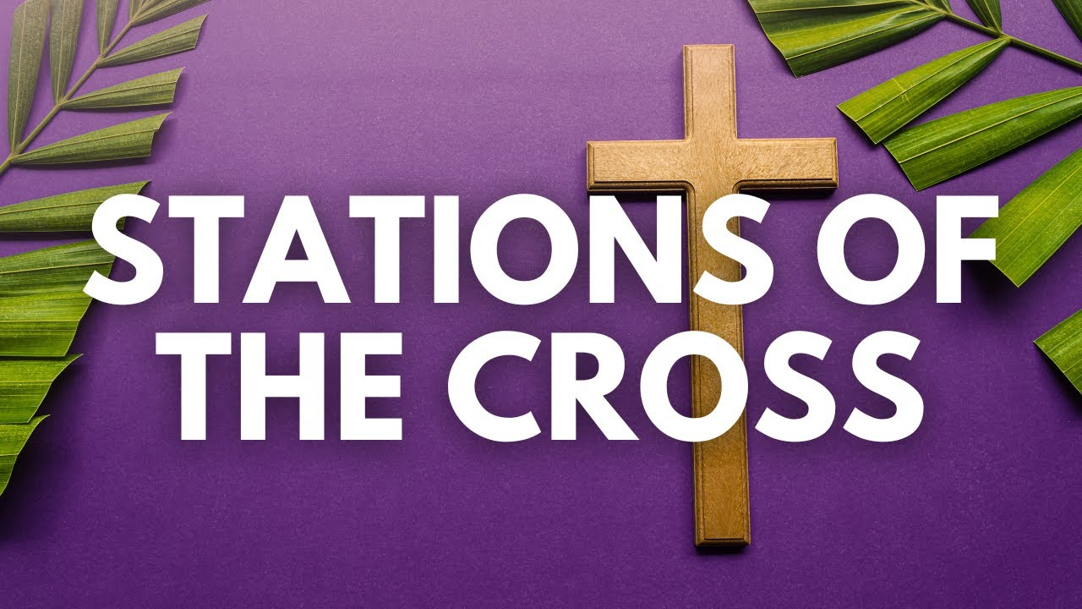

Friday
after 11.00am Mass
GOOD FRIDAY
11.00am Children’s Stations of The Cross

3.00pm Celebration of the Lord’s Passion

7.30pm Stations of The Cross

HOLY SATURDAY

9.00pm EASTER VIGIL

EASTER SUNDAY
Masses: 8.00a.m. 9.30am,
11.00am,& 12.30pm

The Collection at last weekend’s Masses came to £3,185.
Thank you!

