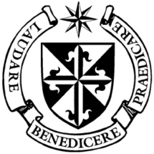
Dominican Newsletter
St. Catherine’s Church, Dominic Street, Newry.
8th February 2026 Tel: Tel: 028 3026 2178 5th Sunday A.
Masses: Vigil: Sat 7.30pm, Sunday: 8.00am, 9.30am, 11.00am, 12.30pm.
Weekdays: 7.30am, 11.00 am, 7.30 pm ( incl. Vigil Sat.)
Confession: Saturday: 11.30am - 12.30pm and 4.00pm – 5.00pm
Website: https://newrydominican.com/ Facebook: www.fb.com/newrydominican
Watch live: newrydominican.com/live Lectio Centre: lectio.newrydominican.com

Youth 2000
13th February
6.45pm to 7.30pm
Blesed Sacrament Chapel
Young Adults welcome

Wednesday 11th February
Feast of Our Lady of Lourdes
On February 11th 1858, Our Lady appeared to Bernadette Soubirous (14) in Lourdes and gave her a series of messages over 14 days.

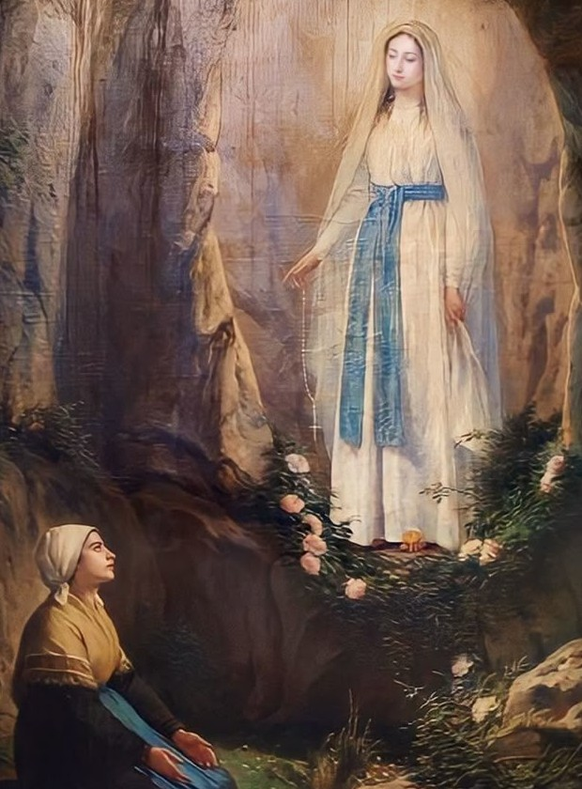

She revealed herself as the Immaculate Conception, just four years after the pope had declared it as a dogma that Mary was conceived without original sin.
Our Lady called people to prayer and penance.
Lourdes is one of the great pilgrimage sites with pilgrims coming to Lourdes from all over the world.
The feast of Our Lady of Lourdes is also World Day of Prayer for the Sick.

Feasts this week
Tuesday 10th St. Scholastica
(Sister of St. Benedict)
11th February
Our Lady of Lourdes
‘World Day of Prayer for the Sick’.

Saturday 14th
St. Cyril & St. Methodias 9th Cent.
...honoured as apostles to
the Slavic people.

St. Cyril’s remains lie in the Irish Dominican Church of
San Clemente in Rome.

St. Brigid’s Crosses
Special thanks to all volunteers who collected rushes, those who helped make St. Brigid's Crosses, to the Lectio Centre and those who helped distribute the crosses at the Masses over the weekend.
The money collected will go towards the upkeep of Priory, Church and Lectio Centre.

‘Let your Light Shine’
(Matthew 5: 13-16)
Jesus wants us to be affirmed, he wants us to know we have much to offer. We are like the ‘salt’, we can make a difference in people’s lives.
We are also like the ‘light’, we can help bring out the best in people’s lives. We can bring hope and new life to people by spending time with them, listening to them and encouraging them.


Our light can also be how we live our lives, in living good lives we can make a good impression in the lives of others and enable them to bring about change in their own lives.
Jesus tells us not to cover the light, have confidence in yourself,you’re your light shine, realize that you can help change people’s lives and bring them closer to the Lord.

‘ ….seeing your good works, they may give the praise to your Father in heaven.’

Prayer of Pope Leo ......

‘Bless the hands of doctors, nurses, and caregivers,
so that their work may always be an expression of active compassion.
May your Spirit enlighten them in every difficult decision, and grant them patience and tenderness to serve with dignity’. Amen.

Knock: Irish bishops launch Vocations Monstrance blessed by Pope Leo
- This week the Irish Bishops formally launched a new monstrance which will be used to gather the faithful for prayerful Eucharistic Adoration for vocations to the Priesthood and Religious life.
- 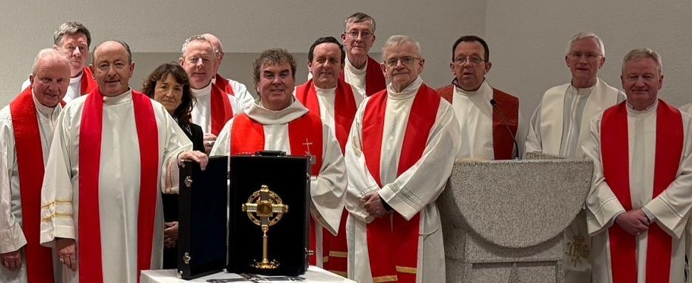
- The Vocations Monstrance was blessed by Pope Leo last November.
- Bishop Cullinan of the Irish Bishops said:
- ’ Our initiative aims to encourage prayer for vocations and to deepen young people's awareness of God's call in their lives. The monstrance will visit dioceses, parishes, schools, and seminaries throughout the country, providing opportunities for Eucharistic Adoration and focused prayer for vocations. Through prayer before the Blessed Sacrament, we ask the Lord to raise up generous and joyful servants for His Church. Vocations are born in prayer, sustained by prayer, and strengthened through prayer’.

Ash Wednesday
18th February
Dromore Diocese
Lourdes Pilgrimage
15th to 20th May
Those wishing to make the pilgrimage please Contact
Sean Gorman 028 3026 3739
or any committee member. Cost £890

The Collection last weekend came
to £3,527 Thank you!

