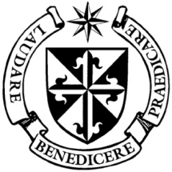
Dominican Newsletter
St. Catherine’s Church, Dominic Street, Newry.
15 ^{th} February 2026 Tel: Tel: 028 3026 2178 6th Sunday Year A.
Masses: Vigil: Sat 7.30pm, Sunday: 8.00am, 9.30am, 11.00am, 12.30pm.
Weekdays: 7.30am, 11.00 am, 7.30 pm ( incl. Vigil Sat.)
Confession: Saturday: 11.30am - 12.30pm and 4.00pm – 5.00pm
Website: https://newrydominican.com/ Facebook: www.fb.com/newrydominican
Watch live: newrydominican.com/live Lectio Centre: lectio.newrydominican.com

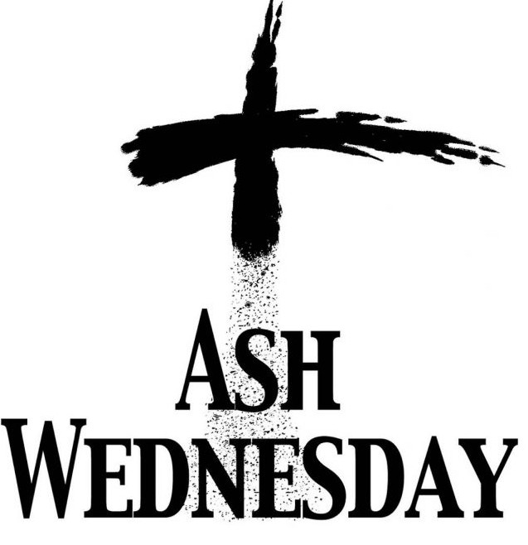
(Day of Fast and Abstinence)
18th February
Masses, 7.30am,11.00am & 7.30pm
Ashes distributed at Masses

Today we begin the season of Lent – 40 days of prayer and fasting, a time when we look at our own lives and make an effort to return to the Lord.
Ashes will be distributed at all Masses. Ashes remind us that when we die we will return to the earth from which we came. We are reminded that the first man Adam was created from the dust of the earth.
Shrove Tuesday
It was traditional to use up excess food before the beginning of Lent by using up eggs and flour etc. Thus began the process of making pancakes and the day was called ‘Pancake Tuesday’ or Shrove Tuesday’ before the lenten fast.
It is also called Carnival Tuesday where people celebrated it as a day of excess before the fasting and penance of Lent.

Pope Leo XIV
…to begin Lent at the Dominican Basilica of Santa Sabina.

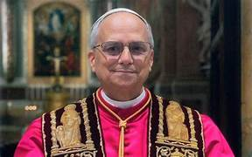

On Feb. 18, Ash Wednesday, Pope Leo XIV will preside over a procession in Rome to the Dominican Basilica of Santa Sabina on the Aventine Hill, marking the beginning of the Lenten season, where he will celebrate Ash Wednesday Mass with the blessing and imposition of ashes.

Santa Sabina is the world headquarters of the Dominican Order with Fr. Carlsyle Fortune O.P. (a member of the Irish Dominican Province) as rector of the Basilica.

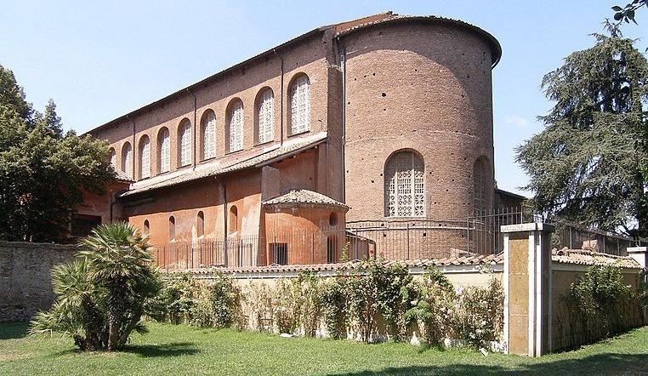

Church Restoration Fund
Country Music
Cabaret Night
Sunday 26th March
8.00pm
Gavin Gribben Band
Hugo Duncan
Leon, Ennis Brothers
Kevin Kearney

Canal Court Hotel
Tickets £25 (available at
Lectio Centre & Canal Court Hotel)

MC: Kevin McAllister

Lent 2026
5 Week Lenten Bible Study
‘Why did Christ have to die?’
Beginning Thursday 19th Feb.
7.00pm in the Dominican hall.

All welcome, tea and biscuits afterwards. Bring your Bible.



Fridays of Lent
after 11.00am Mass

Lectio Divina
for Newcomers

Looking for a simple way to grow closer to Jesus this Lent?
Join our Lectio Series for Newcomers.

Lectio Divina is a gentle,
prayerful way of journeying with Scripture. No prior knowledge of Scripture is required.

If you would like to refresh your faith or try something new, you are warmly invited – just an hour each week and an open heart.

To book your place
Call: 028 302 621 78
Email: lectiomission@gmail.com
or call into the Lectio Centre

Pope Courage International

Pope Leo XIV met at the Vatican with members of Courage International, a Catholic apostolate supporting people with same-sex attraction who seek to live chastely according to the teachings of the Catholic Church.

During the private audience, they spoke about the healing power of chastity, true freedom as mastery of one’s passions, and surrender to God’s will.

Fr. Brian Gannon, Executive Director, said the Pope was very supportive and emphasized that no one is alone and Christ walks with the wounded. The meeting was described as a historic first papal audience for the ministry, active worldwide since 1980.et at the Vatican with members of Courage

Dromore Diocese
2026 Lourdes Pilgrimage
15th to 20th May
Contact: Sean Gorman at
028 3026 3739 Cost £890

The Collection at last weekend’s Masses came to £3,362 . Thank you!

