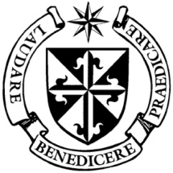
Dominican Newsletter
St. Catherine’s Church, Dominic Street, Newry.
1st February 2026 Tel: Tel: 028 3026 2178 Saint Brigid
Masses: Vigil: Sat 7.30pm, Sunday: 8.00am, 9.30am, 11.00am, 12.30pm.
Weekdays: 7.30am, 11.00 am, 7.30 pm ( incl. Vigil Sat.)
Confession: Saturday: 11.30am - 12.30pm and 4.00pm – 5.00pm
Website: https://newrydominican.com/ Facebook: www.fb.com/newrydominican
Watch live: newrydominican.com/live Lectio Centre: lectio.newrydominican.com

Saint Brigid

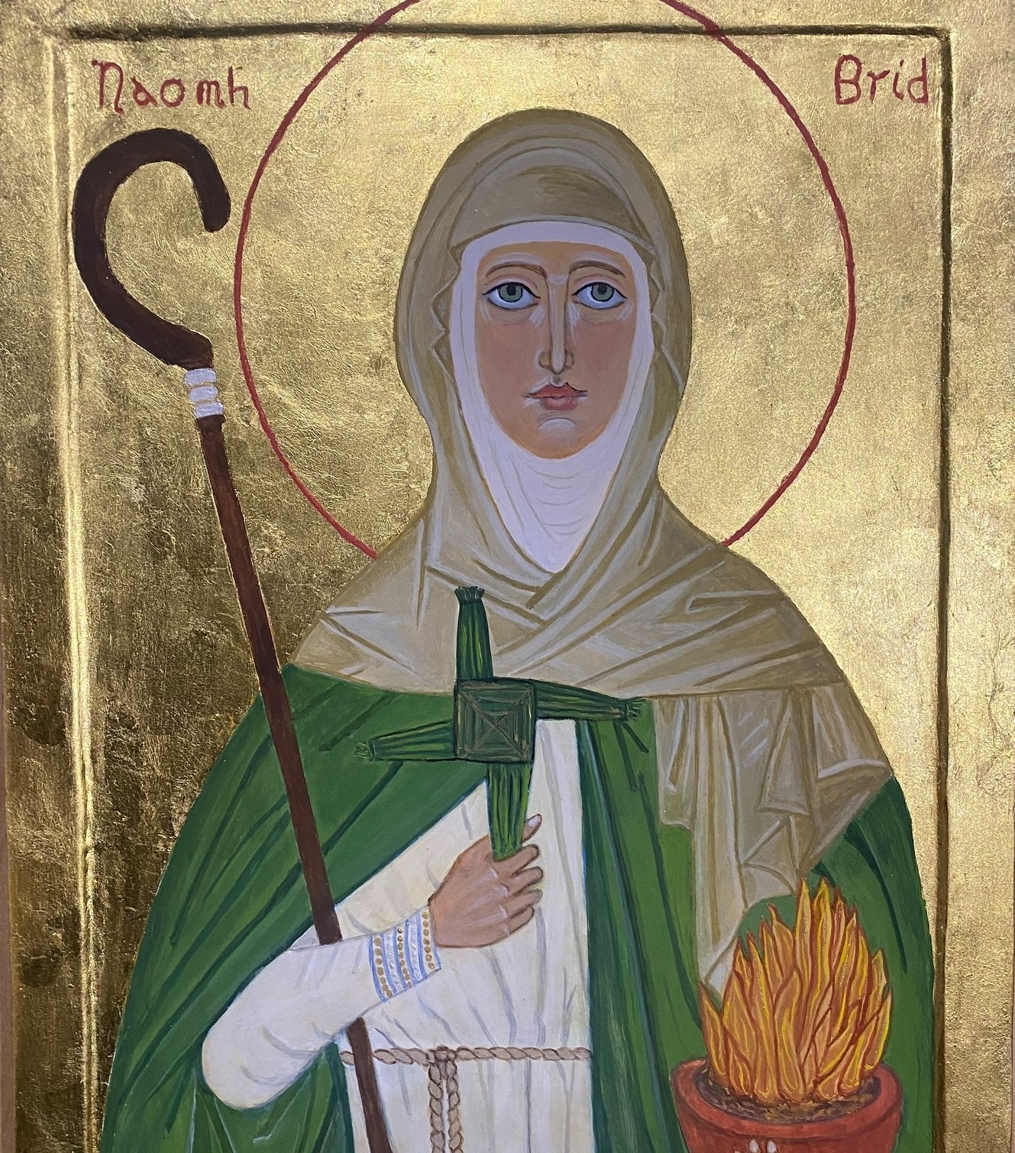Faughart, between Dundalk and Newry is the traditional birthplace of Saint Brigid. It is a place well worth a visit and have places associated with St. Brigid: Saint Brigid’s Holy Well, Saint Brigid’s Pillar, and Saint Brigid’s Bed.
On growing up St. Brigid moved to Kildare where she founded a monastery and went to found various monasteries
Since 2023, the Republic of Ireland has a Public Holiday on the Feast of St. Brigid.

St. Brigid’s Crosses
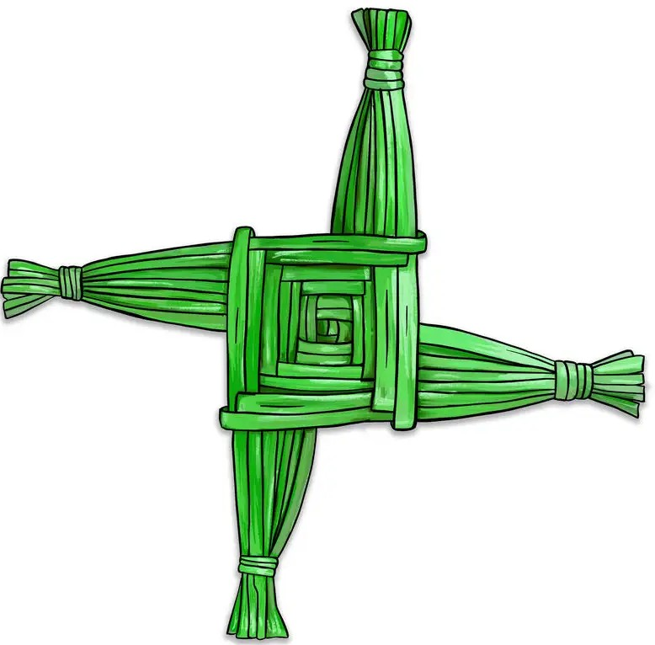

Available at Masses today and also at the Lectio Centre.

St. Brigid’s Blessing

When a St. Brigid’s Cross is brought into the house this Blessing is often used:

May Brigid bless the house wherein we dwell.
Bless every fireside,
every wall and door.
Bless every heart that beats beneath its roof.
Bless every hand that toils
to bring its joy.
Bless every foot that walks
portals through.
May Brigid bless the house that shelters us. Amen

1st Sunday 11.00am Mass
Children’s Liturgy

All Primary School
Children welcome.
Catholics in Greenland
Greenland has been in the news recently over who should own it.
Greenland is the world’s largest island.
There is a tiny Catholic community of about 800 Catholics in Greenland with one Catholic priest ministering to the community, Fr. Tomaz Majcen is a Franciscan from Slovenia. He is based in Nuuk, the capital.

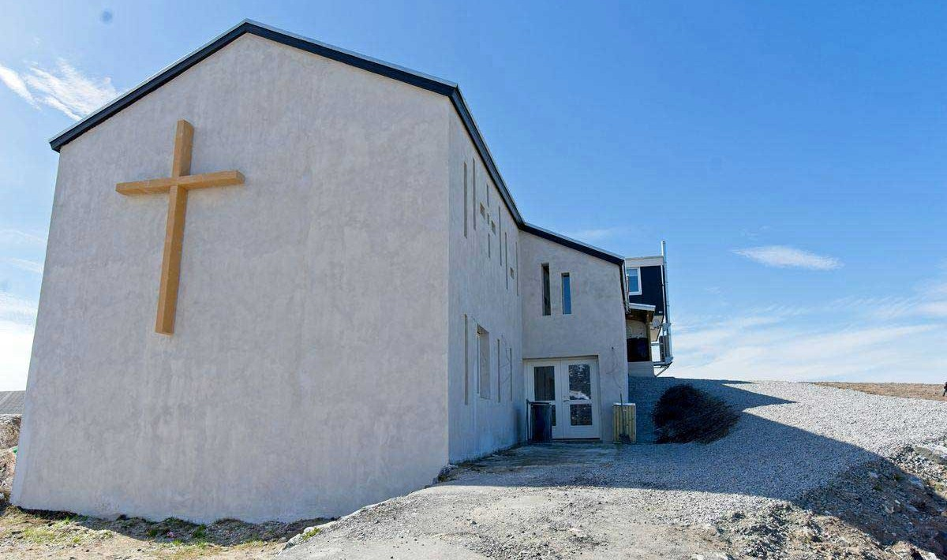

He celebrates daily Mass in Christ the King parish Church (the only Catholic Church). He frequently travels to outlying towns to visit Catholics scattered across the country. 

‘The recent talk about Greenland causes confusion and anxiety among the people’ Fr. Majcen said especially when the talk is about ‘taking control’ or ‘annexation’. ‘Our fragile Artic environment is one of God’s most impressive – and most vulnerable – masterpieces’ he said ‘Caring for it is about also respecting those of us who live there’.

Anointing of the Sick
Monday
7.30pm Mass

Today 1st February
Divine Mercy Holy Hour
3.00pm

Dromore Diocese
Lourdes Pilgrimage
15th to 20th May
Those wishing to make the pilgrimage please Contact
Sean Gorman 028 3026 3739
or any committee member.
Cost £890

Tuesday February 2nd 2025
The Presentation
of the Lord
(World Day for Consecrated Life)
On this day we remember and pray for those in Religious Life.
Candlemas
- with blessing of candles.
If you wish to have Candles blessed on Tuesday please bring candles with you to the Mass.

The Collection last weekend came to
£3,427 Thank you!

