
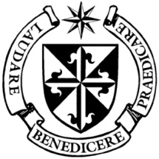
Dominican Newsletter
St. Catherine’s Church, Dominic Street, Newry.
4th January 2026 2nd Sunday of Christmas
Masses: Vigil: Sat 7.30pm, Sunday: 8.00am, 9.30am, 11.00am, 12.30pm.
Weekday Masses: 11.00 am, 7.30 pm, 7.30pm (Vigil Sat.)
Confession: Saturday: 11.30am - 12.30pm and 4.00pm – 5.00pm
Website: https://newrydominican.com/ Facebook: www.fb.com/newrydominican
Watch live: newrydominican.com/live Lectio Centre: lectio.newrydominican.com

‘Look, there is
the lamb of God’.

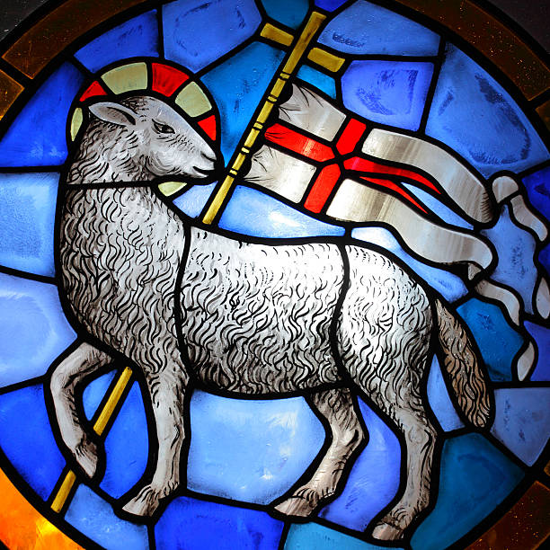

At the heart of the vision at Knock Shrine is the Lamb of God standing on an altar with the cross above the altar.
Today John the Baptist is pointing out Jesus to the disciples and told them that Jesus is the ‘Lamb of God’. The disciples went on and told others that they had found the Messiah.
During the Passover the Israelites sacrificed a lamb and marked their doorposts with its blood. In the New Covenant the death of Jesus coincided with the Passover marking a new covenant between God and the people. The blood of the lamb gave protection to the people while the blood of Jesus offers spiritual protection and freedom from bondage. Jesus the Lamb frees us from the bondage of sin.
‘Lamb of God who takes away the sins of the world grant us peace’

Tuesday 6th January

EPIPHANY OF THE LORD
(Holy Day of obligation)


Vigil Mass

Monday 7.30pm
(No Anointing of the Sick)

Tuesday 6th January

7.30am, 11.00am & 7.30pm



HAPPY NEW YEAR!
As we begin 2006 we wish you all a very Happy New Year. We pray that God’s Blessings with be with you throughout the year and that it will be a year of peace and filled with faith and trust in God.
‘May the Peace of God be
with you in 2026. Amen’.
Amen

The Holy Year of Hope
finishes on January 6th
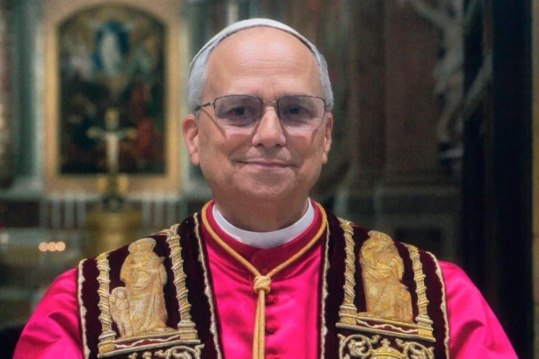

Pope Leo XIV will conclude Jubilee year by closing the Holy Door in St. Peter’s Basilica in the Vatican on
6th January – the Solemnity of the Epiphany.
Earlier in the year before Pope Francis passed away, he announced the closing of the Holy Door and expressed his hope: “That the light of Christian Hope may illumine every man and woman as a message of God’s love addressed to all! and ‘may the Church bear faithful witness to this message in every part of the world!”

2026 Diary Dates

Ash Wednesday: 18th February 2026

Palm Sunday: 29th March 2026

Easter Sunday: 5th April 2026

Pentecost: 24th May 2026

Corpus Christi: 7th June 2026

THNK YOU!
Thank you to all our helpers especially those who helped during the Christmas season. There was much to prepare for Christmas, and we are very grateful for all those who helped in any way.
Your help is very much appreciated.

Thank You!

Where Pope Leo might visit in 2026

On his way back from Turkey Pope Leo was asked by journalists on the flight where he might visit in 2026?
"As for trips, nothing is certain yet. I hope to make a trip to Africa. That would possibly be the next trip," he said. "Personally, I hope to go to Algeria to visit the places from the life of St. Augustine, but also to continue the dialogue, building bridges between the Christian world and the Muslim world."
He also said that he was "working on some other countries," including several in Latin America.
"Obviously, I would love to visit Latin America; Argentina, and Uruguay are waiting for the pope’s visit. Peru, I think they will receive me, too! And then, if I go to Peru, (I could visit) many neighboring countries as well. But the plan is not yet defined," he said.

MONDAY COLLECTION

From January the Monday
St. Martin Collection will go towards the ‘Sanctuary’ whose aim is to provide a safe and enlightened environment for all who suffer with Mental Health and is based at Dominic Street. Their meetings take place in the Dominican Hall.

HAPPY NEW YEAR!
The Lectio Centre
will re-open on
Friday 2nd January.

Last Sunday’s Collection
came to £3,081 Thank you!

Kind regards,

John

Thank you!

