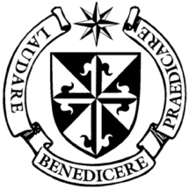

**Dominican Newsletter**

***St. Catherine’s Church, Dominic Street, Newry.***

**5th October 2025 Rosary Sunday**

**Masses:**  **Vigil:** Sat 7.30pm, **Sunday**: 8.00am, 9.30am, 11.00am, 12.30pm.

Weekdays: 7.30am, 11.00 am, 7.30 pm *(Vigil Sat.)*

Confession: Saturday: 11.30am - 12.30pm and 4.00pm – 5.00pm

**Website:** <https://newrydominican.com/> **Facebook**: [www.fb.com/newrydominican](http://www.fb.com/newrydominican)

**Watch live**: newrydominican.com/live **Lectio Centre**: lectio.newrydominican.com

**Rosary Sunday**



The ***"Blessing of Roses"*** is a Catholic and Dominican tradition, where roses are blessed on Rosary Sunday for the healing and protection of the sick and to ward off evil spirits. The roses remind us of Our Lady of the Rosary and the power of the Rosary.

The Blessing with a sprinkling of holy water is a prayer that God’s grace will be upon the Roses and that they will help bring about alleviation from illness and be a protection against all evil.

Today

Annual Collection

Education and Training of Dominican Students

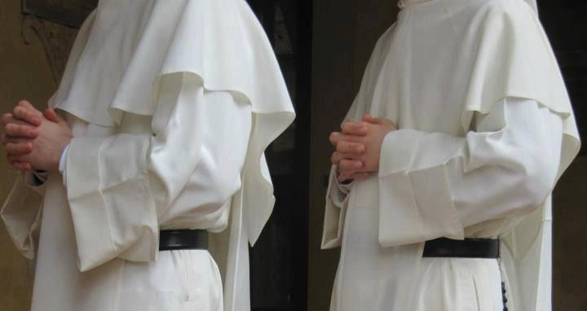

The Offertory Collection this weekend goes towards the *Education of our Dominican Students.*

Two of our Dominican student brothers will speak at Masses. Fr. John Melvin O.P. and Br. James Grady are with us this weekend.

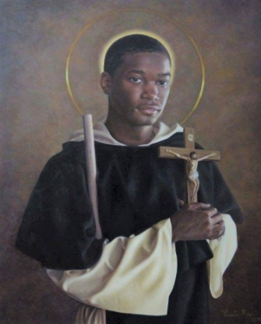

**St. Martin Novena**

3rd to 11th November

Weekdays 11.00am and 7.30pm

Sunday 12.30pm and & 7.30pm

Preacher Fr. Damian Polly O.P.

*Blessing of Pets Sunday 9th November*

*at the Dominican Park opposite the Church*

[Pope's October prayer intention: *'Collaboration among religions'﻿*](https://r.spclists.va/r.html?uid=F.hqJfYwGiX2zNA_aiX23NgHGiX3LOAATskKJfc85o3EYFol91zgAIImY.a8IEqBnjFM5DDD1K0b-cOpOANkJ6ivgzD5vkhjlVpbDCLjlo3TRuyiE2hB_DnH1h9Zs3gVkhbCc4pKzkydp6aQ)

Pope Leo XIV released his prayer intention for the month of October, inviting the faithful to pray for *'collaboration between different religious traditions.'*

Dominican Pilgrimage

to Knock Shrine

Next Sunday 12th October

*We have two buses going from Newry. Bookings are now closed.*

**Today’s Gospel:** Luke   17: 5-19

**‘Were your faith the size of a mustard seed you could say to this mulberry tree,**  
“***B*e uprooted and planted in the sea”**,

**and it would obey you.**

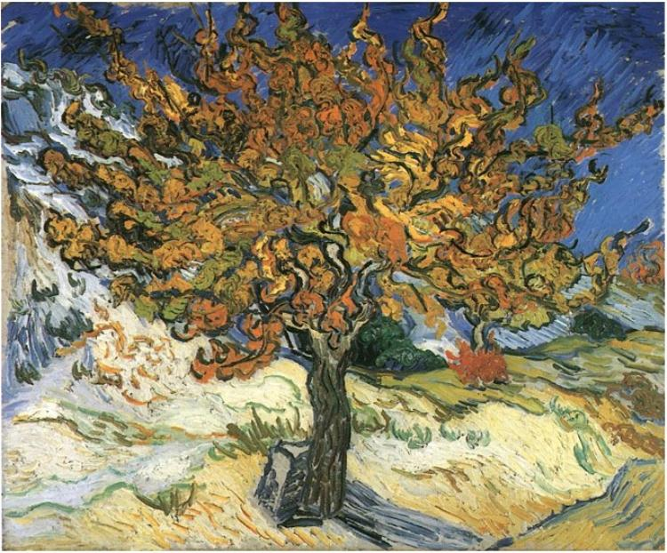

The Gospel calls on us to believe in ourselves and reminds us that with a strong faith we can do great things‘

‘When you have done all you have been told to do, say, *“****W***e are merely servants: we have done

no more than our duty”.’

**Divine Mercy Holy Hour**

**Today 3.00pm** *(First Sunday)*

**Youth 2000**

**2nd Friday** *(10th Oct.)*

**6.45pm to 7.30pm**

*Blessed Sacrament Chapel*

*Young Adults especially welcome*

1st Sunday 11.00am Mass

Childrens’ Liturgy

*All Primary School Children welcome*

First Monday 7.30pm Mass

Sacrament of the Sick

*The Sacrament will be administered*

*to those who are in need of it.*

Lectio Centre Opening Times

*Mon.- Fri. : 10.00am to 3.00pm*

*Saturday: Closed*

*Sunday: 10.00am to 1.30pm*

*For Mass bookings and Mass Cards etc.*

Monday Morning Tea/Coffee

*after 11.00am Mass*

*...a great place to meet up with friends*

Pope Leo XIV reminds us that *October is the* ‘Month of the Rosary’ and encourages us to pray the Rosary during October ‘for peace’.

**Pope Leo** *appointed* [*Archbishop Filippo Iannone O.Carm 67 prefect of Dicastery for Bishops*](https://press.vatican.va/content/salastampa/it/bollettino/pubblico/2025/09/26/0674/01198.html)*, the position Pope Leo held before he became pope. He was ordained priest the same year as Pope Leo. He spent time as auxiliary bishop of Naples.*

Feasts this Week .......................

Monday 6th St. Bruno grew up in *Germany and founded the Carthusians*

*He died in 1101*

Tuesday 7th Our Lady of the Rosary

Saturday 11th St. John XXIII

Church Collection Sunday Masses (27th/28th September 2025)

was £2,730. *Thank you!*

*Please feel free to take copies of the Newsletter to those housebound and for others.*