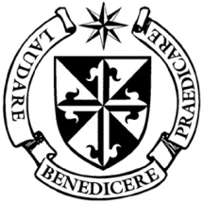

**Dominican Newsletter**

***St. Catherine’s Church, Dominic Street, Newry.***

**12th October 2025**28th Sunday Year A**, PRISONERS SUNDAY**

**Masses:**  **Vigil:** Sat 7.30pm, **Sunday**: 8.00am, 9.30am, 11.00am, 12.30pm.

Weekdays: 7.30am, 11.00 am, 7.30 pm *(Vigil Sat.)*

Confession: Saturday: 11.30am - 12.30pm and 4.00pm – 5.00pm

**Website:** <https://newrydominican.com/> **Facebook**: [www.fb.com/newrydominican](http://www.fb.com/newrydominican)

**Watch live**: newrydominican.com/live **Lectio Centre**: lectio.newrydominican.com

***Praising God …….***

Leprosy was a horrible illness

with no cure and those infected

had to be isolated and kept

apart from others. To be healed

by Jesus was a wonderful

healing for them as they could

now return to their former lives.

Only one of them returned to Jesus to say thanks and rejoiced praising God.

Thanksgiving is so important for us. Many of us take things for granted and never thank God for his blessings and help. May we always remember Gospel and the leper thanking Jesus for his healing. May it remind us of always saying thanks to God and to those who help us in any way.

This act served as a public testimony of their healing, allowed for the prescribed [Levitical sacrifices](https://www.google.com/search?rlz=1C1GCEA_enGB1175GB1175&cs=0&sca_esv=579135331b5c96bb&q=+Levitical+sacrifices&sa=X&ved=2ahUKEwjo8-Cd0pGQAxUOWEEAHbUuHOIQxccNegQIAxAB&mstk=AUtExfBiMgsMZIQOSMx0SLuDNRK30A0YcTYXsxQR6IBHl0bts2pRaBuBAbsMya-2GQRDnlPFB6osxusssAYmDW9sW41TxN0cL_GdpJAi5pGE0hMIoP6OyQ1f0_7VpurYse3i-lk&csui=3), and demonstrated Jesus' respect for the Law, showing he was not abolishing it but fulfilling it

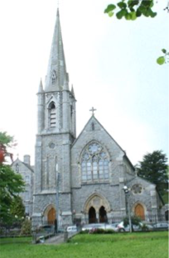150th

Anniversary

Dominican Church Newry

Friday 17th October

11.00am Mass

Present will be

Fr. Gerard Timoner O.P.

Master of the

Dominican Order

and

Archbishop

Eamon Martin

*Afterwards there will be a gathering in the Dominican Hall.*

All welcome!

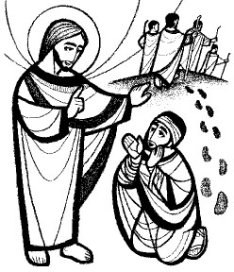

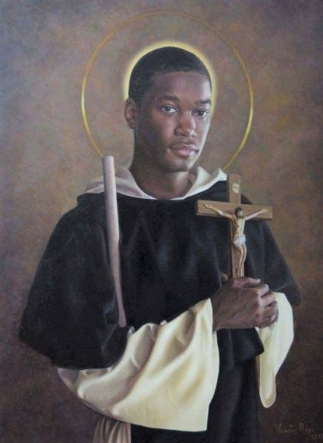

**St. Martin Novena**

**3rd to 11th Nov.**

Weekdays

11am & 7.30pm

Sunday

12.30pm & 7.30pm

Preacher

Fr. Damian Polly O.P.

Blessing of Pets:

*Sunday 9th November in Park opposite the Church*



Today Sunday 12th October is ‘PRISONERS SUNDAY’

Today’s *‘Day of Prayer for Prisoners’* encourages visits to prisoners and their families and emphasises the importance of offering hope and mercy.

Also in December 14th Pope Leo will also have a Jubilee Mass for Prisoners to celebrate a Year of Hope and to remember those in prison.

*Pray for those in prison*

[Pope's October prayer intention:](https://r.spclists.va/r.html?uid=F.hqJfYwGiX2zNA_aiX23NgHGiX3LOAATskKJfc85o3EYFol91zgAIImY.a8IEqBnjFM5DDD1K0b-cOpOANkJ6ivgzD5vkhjlVpbDCLjlo3TRuyiE2hB_DnH1h9Zs3gVkhbCc4pKzkydp6aQ) *['Collaboration among religions'﻿](https://r.spclists.va/r.html?uid=F.hqJfYwGiX2zNA_aiX23NgHGiX3LOAATskKJfc85o3EYFol91zgAIImY.a8IEqBnjFM5DDD1K0b-cOpOANkJ6ivgzD5vkhjlVpbDCLjlo3TRuyiE2hB_DnH1h9Zs3gVkhbCc4pKzkydp6aQ)*

Pope Leo XIV releases his prayer intention for the month of October, inviting the faithful to pray for 'collaboration between different religious traditions.'

Lectio Centre Opening Times

*Mon.- Fri. : 10.00am to 3.00pm*

*Saturday: Closed*

*Sunday: 10.00am to 1.30pm*

*For Mass bookings and Mass Cards etc.*

Presentation of cheque

for Renovation Fund for the Church.

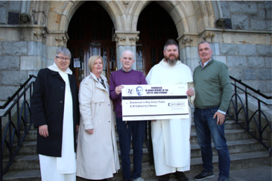Fundraiser in memory of the later Fr. John O’Rourke O.P. raised £11,226 - divided between Newry Dominican Renovation fund and Dominicans in Tralee where

Fr. John spent his last years.

Our prayers go with those from Newry on the Dominican Pilgrimage to Knock today.

The Choir Studio

*Presents*

Songs of Light and Hope

An evening of music, hope and reflection in support of the Lectio mission.

Sunday 19th October

Dominican Church Newry

at 6.00pm

Featuring

*The Uplifted Gospel Choir*

*The Young at Heart*

*The Shining Light Choir*

*Fr. Joseph Ralph and the Lectio Community*

*Please feel free to take copies of the Newsletter to those housebound and for others.*

Monday Morning Tea/Coffee

*after 11.00am Mass*

*...a great place to meet up with friends!*

Annual Church Collection for the Education of Dominican Student Brothers came to Sunday to £5,155 and €720

*The Dominican Province is very grateful to you the people of Newry for your support. Your offerings are a big help big in the formation of our student brothers.*

*Thank you!*

*Thank you!*