

**Dominican Newsletter**

***St. Catherine’s Church, Dominic Street, Newry.***

**31st August 2025 22nd Sunday Year C**

**Masses:**  **Vigil:** Sat 7.30pm, **Sunday: 8.00am, 9.30am, 11.00am, 12.30pm.**

Weekdays: 7.30am, 11.00 am, 7.30 pm *(Vigil Sat.)*

Confession: Saturday: 11.30am - 12.30pm and 4.00pm – 5.00pm

**Website:** <https://newrydominican.com/> **Facebook**: [www.fb.com/newrydominican](http://www.fb.com/newrydominican)

**Watch live**: newrydominican.com/live **Lectio Centre**: lectio.newrydominican.com

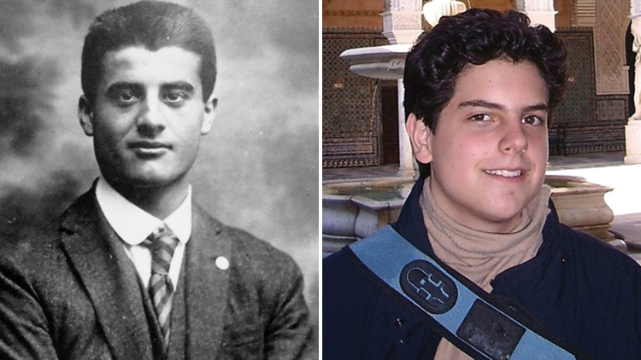

**Pier Georgio Frassiti Carlo Acutis**

**Sunday - September 7th**

Canonisations

Blessed Pier Giorgio Frassati O.P. and Blessed Carlo Acutis

Pier Georgio Frassiti was born in Turin in 1901. He loved mountain climbing with his friends. He is known for his great charitable outreach to the poor and needy. He was a member of the Dominican Third Order. He was very much dedicated to social justice. He was also a member of St. Vincent de Paul. He died in 1925 from Polio.

He is now another Dominican added to the list of Dominican Saints!

******************************

**CARLO ACUTIS will be celebrated in Newry Cathedral on Sunday 7th Sept. with Mass at 5.30pm. All Welcome especially Families and Young People**

*Refreshments Afterwards in Newry Parish Centre*

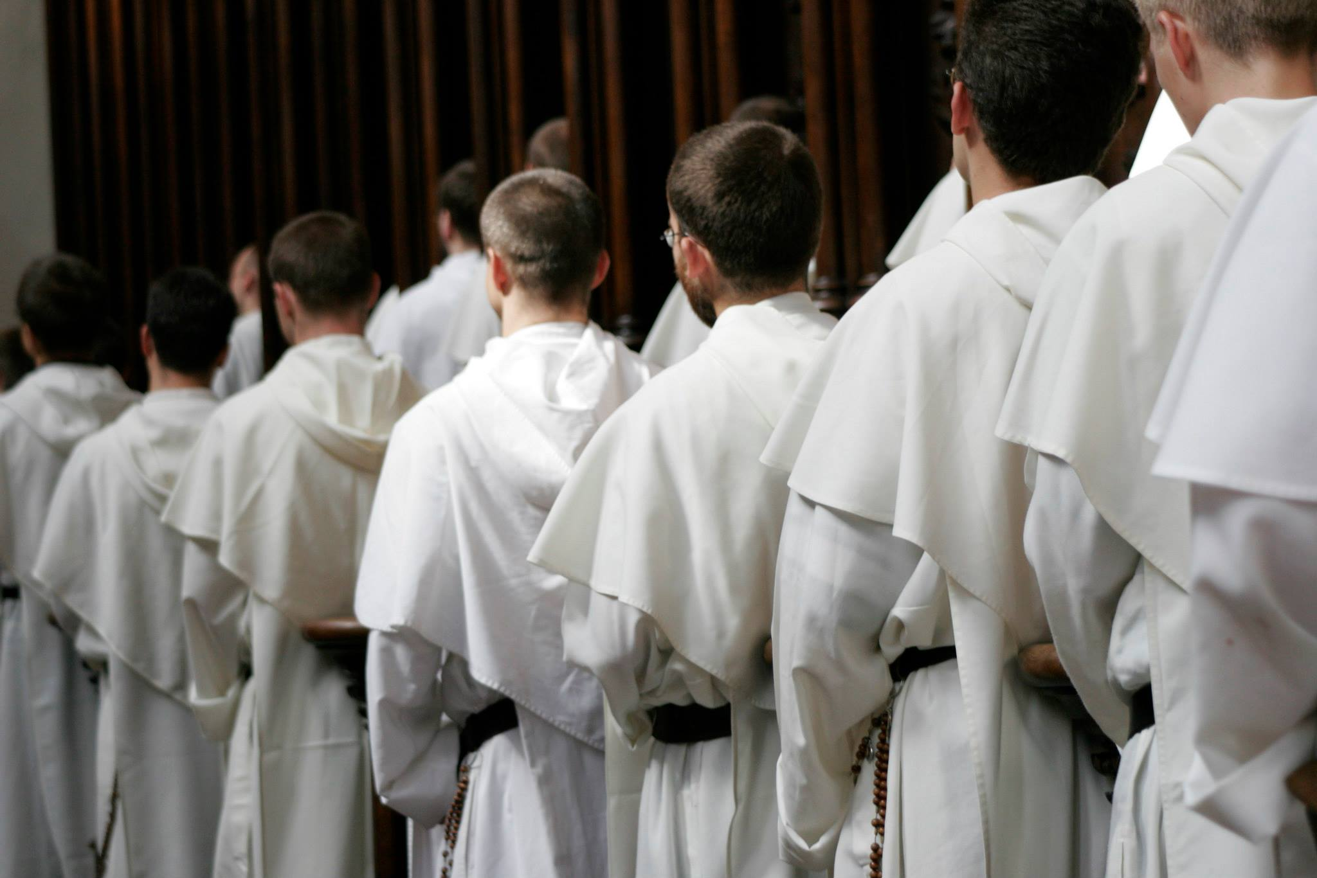

World Meeting of

Dominican Friars

(General Chapter)

The recent General Chapter of Dominican Friars *from around the world* took place in Cracow - Poland in July/August. Fr. John Harris (Provincial) represented the Irish Dominicans. Aspects of Dominican life and its work were discussed and reviewed.

The Chapter agreed to have the next Dominican General Chapter in Columbia in 2028, which will elect a new Master of the Order.

Last Tuesday there was an Assembly of Dominicans in Tallaght, Dublin in preparation for the Irish Provincial Chapter taking place.

Up to 65 Dominicans attended the Assembly day in Tallaght.

*Please remember the Irish Dominican Province in your prayers at this time.*

*‘For everyone who exalts himself will be humbled, and the man who humbles himself will be exalted.’*

Luke     14:1. 7-14

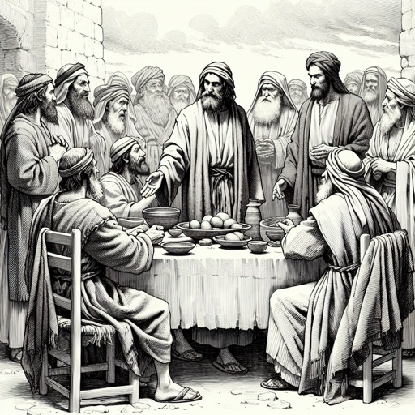

It can be amusing when people come to Mass, most resist coming up to the seats at the front and prefer the seats at the back of the Church. Then at music concerts when famous are on stage, people want to get the best seats and like the front to be close to the performance.

Similarly there are people who like to boast about the important or famous people they have met, or what countries they have been to. There are times we like to show off what we have or are wearing.

In today’s gospel Jersus tells us to be humble. God sees all we do and will reward those who are humble and those who reach out to those who have less that you.

*‘ When you have a party, invite the poor, the crippled, the lame, the blind; that they cannot pay you back means that you are fortunate, because repayment will be made to you when the virtuous rise again.’*

vvvvvvv

Lectio Centre

Opening Times

*Mon.- Fri. : 10.00am to 3.00pm*

*Saturday: Closed*

*Sunday: 10.00am to 1.30pm*

*Mass bookings and Mass Cards etc.*

**LECTIO DIVINA CENTRE**

***Introduction to Lectio Divina***

***Five Saturdays***

**beginning 13th September**

**10.30am to 12noon**

Further details & Booking:

Tel: 028 30262178

Email: lectiocentre35@gmail.com

Dominican Pilgrimage to Knock

Sunday 12th October 2025

*Details later*

*First Friday of the month.*

Friday 5th September

Sacrament of the Sick

Monday - 1st September

7.30pm Mass

Monday Morning Tea/Coffee *resumes tomorrow 1st September after 11.00am Mass*

**Divine Mercy**

Holy Hour *(First Sunday)*

Next - Sunday - 3.00pm

Last Sunday’s Collection was £3,080

*Thank you!*

*Please feel free to take copies of the Newsletter to those housebound and for others.*