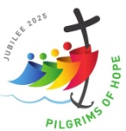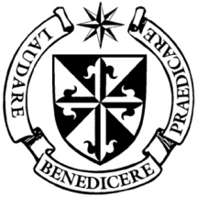

**Dominican Newsletter**

***St. Catherine’s Church, Dominic Street, Newry.***

**8th June 2025** Tel: 028 3026 2178 **PENTECOST**

**Masses:**  **Vigil:** Sat 7.30pm, **Sunday**: 8.00am, 9.30am, 11.00am, 12.30pm.

Weekdays: 7.30am, 11.00 am, 7.30 pm *(Vigil Sat.)*

Confession: Saturday: 11.30am - 12.30pm and 4.00pm – 5.00pm

**Website:** <https://newrydominican.com/> **Facebook**: [www.fb.com/newrydominican](http://www.fb.com/newrydominican)

**Watch live**: newrydominican.com/live **Lectio Centre**: lectio.newrydominican.com

POPE LEO XIV

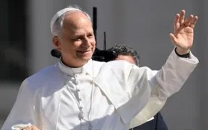

*During his weekly General Audience, Pope Leo XIV reminded pilgrims that God waits for us with open arms, no matter how late we are in responding to His call. He told young people that if they are seeking meaning in Life, God will offer it to them and never disappoint . "God never gives up on us; he is always ready to accept us and give meaning and hope to our lives, however hopeless our situation may seem and however insignificant our merits may appear”.*

Pentecost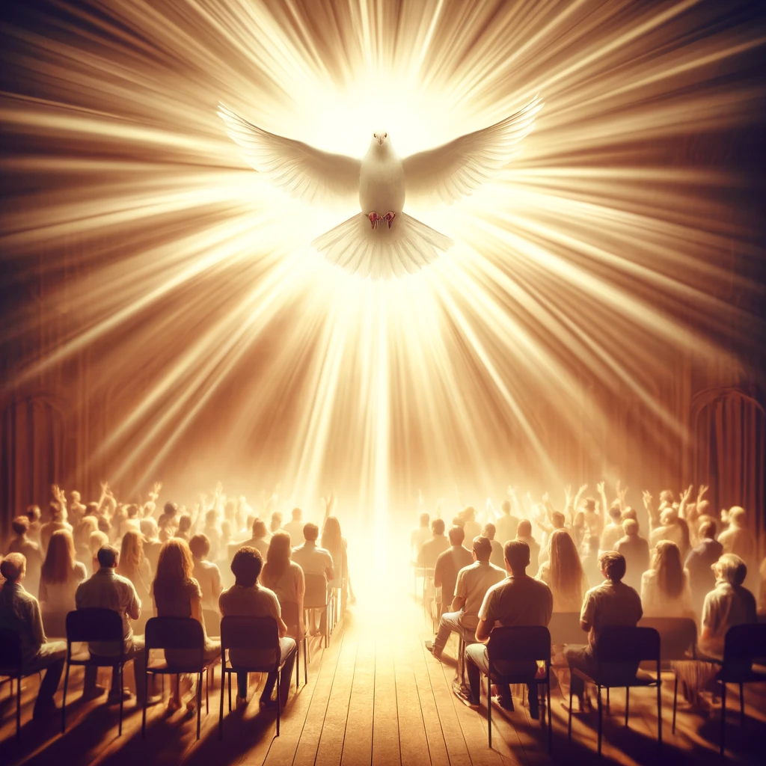

Today we remember the outpouring of the Holy Spirit at Pentecost. God’s power comes upon us with the coming of the Holy Spirit. The Holy Spirit brings God’s grace and is present in the Sacraments. The Holy Spirit was present at the Creation of the World, with the Spirit hovering over the waters and bringing life. The Spirit is often described as the *‘breath of God’*. In Baptism it is the Holy Spirit who immerses us in Christ, then in Confirmation it is Christ who fills us with the Holy Spirit. *As St. Paul says: “Didn’t you realise that you were God’s temple and that the Spirit of God was living among you’.*

Dromore Diocesan

Pigrimage to Lourdes

We remember all those heading to Lourdes this week on the Dromore Diocesan Pilgrimage. Fr. Adrian will be representing the Dominican on the pilgrimage and will remember your intentions in Lourdes

The Sacred Heart

*This year marks the 350th anniversary of the Sacred Heart revelations to Saint Margaret Mary Alacoque at Paray-le-Monial in France.*

*The Relics of St Margaret Mary Alacoque and St Claude are at the Sacred Heart Church, Cloghogue, Newry, for one week. All are welcome.*

S M A

Dromantine Sunday

*FAMILY FUN DAY*

*Games, l ive Music,*

*Face painting, Food Stalls,*

*Bouncy Castle, Raffle Draw.*

Today Sunday 8th June

1.00pm – 5.30pm

The SMA Fathers, Dromantine

thank you for your support!

FEASTS THIS WEEK

Monday 9th June ST. COLUMBA

Columba was born in Donegal in 521. He founded monasteries in Derry, Durrrow and Iona island off Scotland which became the centre of his mission. He died 9th June 597.

Wednesday 11th St. Barnabas Apostle

Barnabas was born in Cyprus. He was a companion of St. Paul. He returned to Cyprus to continue his work preaching the Gospel and died there.

Friday 12th  ST. ANTHONY

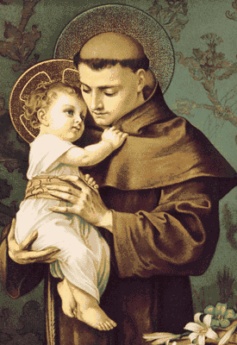

St. Anthony was born in Lisbon, Portugal in 1231. He joined the Franciscans and preached in France and Italy. He is remembered as a great preacher.

St Anthony is venerated all over the world as the Patron Saint for lost articles, and is credited with many miracles involving lost people and lost articles.

*‘Come, Holy Spirit, fill the hearts of your faithful  
and kindle in them the fire of your love.’*

Sponsored Walk

*Due to a Concert being held in the Dominican Church in Aid of The Gateway Club on Sunday 15th June in the Sponsored Walk in Aid of the Repairs and Refurbishments of the Church will be held a week earlier on Sunday 8th June 2025, leaving Camlough at 3pm to the Dominican for Refreshments. On Sunday 1st June and Sunday 8th June after each Mass if anyone would like to Sponsor us or maybe take a Sponsor Card and join us in the Walk to help with the badly needed repairs to the Church we would be very grateful.*

Collection for Sunday 1st June

was £2,840 Thank you.