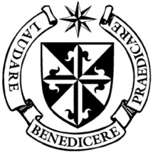

**Dominican Newsletter**

***St. Catherine’s Church, Dominic Street, Newry.***

**29th June 2025 SAINTS PETER AND PAUL**

**Masses:**  **Vigil:** Sat 7.30pm, **Sunday**: 8.00am, 9.30am, 11.00am, 12.30pm.

Weekdays: 7.30am, 11.00 am, 7.30 pm *(Vigil Sat.)*

Confession: Saturday: 11.30am - 12.30pm and 4.00pm – 5.00pm

**Website:** <https://newrydominican.com/> **Facebook**: [www.fb.com/newrydominican](http://www.fb.com/newrydominican)

**Watch live**: newrydominican.com/live **Lectio Centre**: lectio.newrydominican.com

Saints Peter and Paul

Today 29th June is the feast of saints Peter and Paul. Together, the two saints are honoured as the founders of the Church in Rome, through their preaching, ministry and martyrdom.

In a sermon in the year 395, St. Augustine of Hippo said of Sts. Peter and Paul: *“Both apostles share the same feast day, for these two were one; and even though they suffered on different days, they were as one. Peter went first, and Paul followed. And so we celebrate this day made holy for us by the apostles' blood. Let us embrace what they believed, their life, their labours, their sufferings, their preaching, and their confession of faith.”*

**St. OLIVER PLUNKETT**

**Feast: Tuesday 1st July**

This year is the **400th Anniversary** of the birth of St. Oliver Plunkett and 50 years since his canonisation. St. Oliver is a local saint and was Archbishop of Armagh.

During the year we had a visit at Masses by Canon Benny Fee talking about the book on St. Oliver he wrote for Oliver’s Plunkett’s 400th Anniversary.

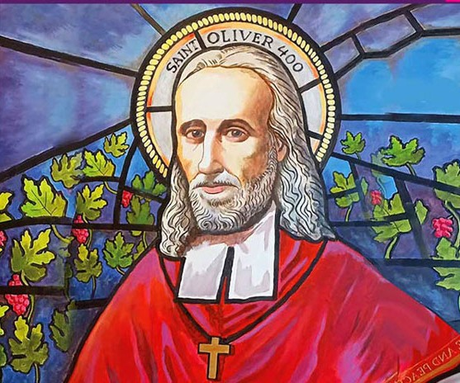

In 1681 Oliver Plunkett was found guilty of treason, hanged , drawn and quartered at the age of 55. After his death his head remained in the care of the Dominican Nuns in Drogheda, St. Oliver’s grandniece was the Prioress at the time.

The head of St. Oliver is now on display in St. Peter’s Church in Drogheda and a visit there reminds us of the horrible death he endured because of his Catholic faith.

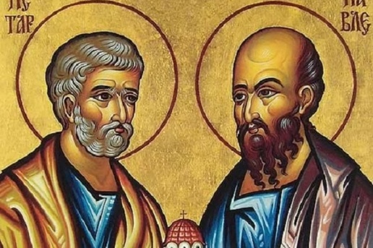

*Monday* Morning *Tea/Coffee in Dominican Hall after 11.00am Mass*

Feasts This Week

Tue. 1st June

ST.OLIVER PLUNKETT

Thursday 3rd June

ST. THOMAS *(Apostle)*

Friday 4th June First Friday

Lectio Centre

New Opening Times

*Mon.- Fri. : 10.00am to 3.00pm*

*Saturday: Closed*

*Sunday: 10.00am to 1.30pm*

*Mass bookings and Mass Cards etc.*

Assisted Dying/ Assisted Suicide Bill in UK

MPs have just voted by 314 votes to 291 in support of the Assisted Suicide Bill. This is a reduced majority of 23, down from the 55-vote majority the Bill had at Second Reading. The Bill now proceeds on to the House of Lords.

Archbishop John Sherrington, Lead Bishop for Life Issues at the Bishops Conference, said in a statement: *'The Bishops of England and Wales have been consistent and outspoken in their opposition to the legalisation of assisted suicide, and we are shocked and disappointed that MPs have voted in favour of the Terminally Ill Adults (End of Life) Bill. This Bill is flawed in principle with several provisions that give us great cause for concern*’.

*'The Catholic Church believes in promoting a culture of life and compassionate care. Allowing the medical profession to help patients end their lives will change the culture of healthcare and cause legitimate fears amongst those with disabilities orthose who who are especially vulnerable in other ways’.*

Mobile Phones

We remind you to please place mobile phone on ‘silent’ when in the Church so as not to disturb others especially during Mass. Thank you.

Receiving Holy Communion

*During the pandemic those who wished to receive Holy Communion on the tongue were asked to go to the priest. Now those who wish to receive Communion on the tongue can go to any Eucharist Minister or the Priest.*

Also if receiving on the hand please place one palm of the hand on top of the other and consume the host before returning to your seat.

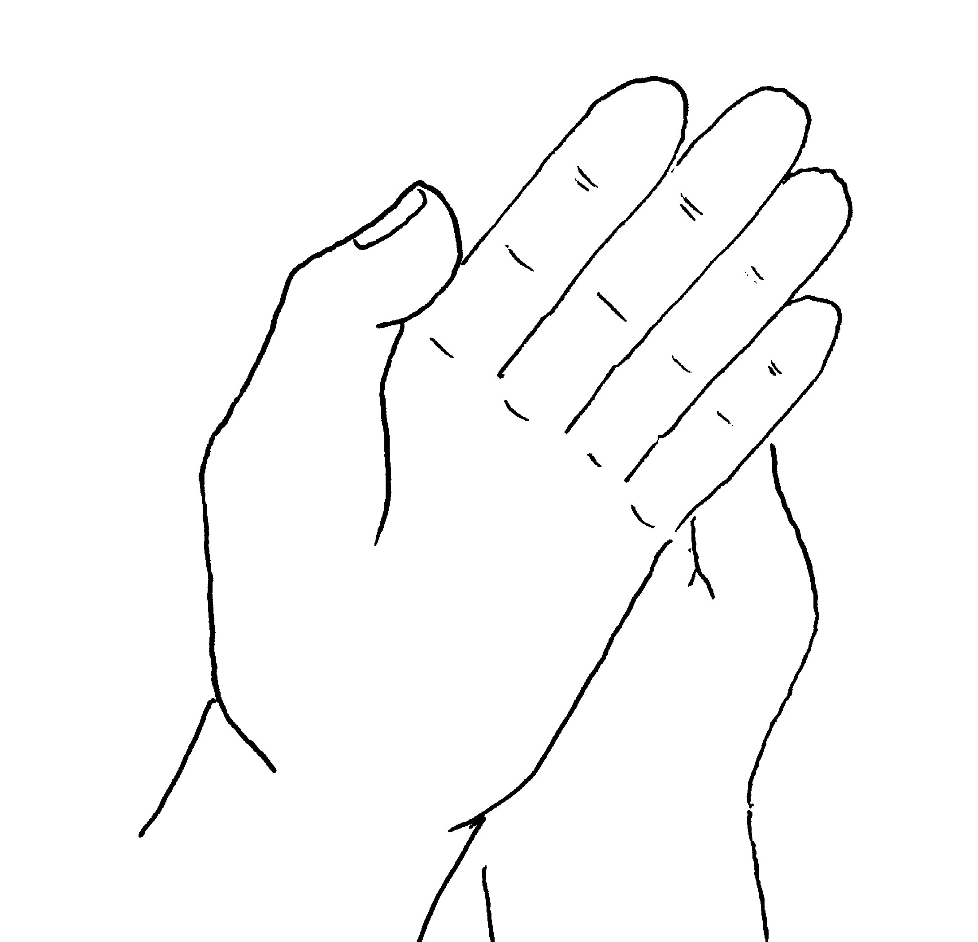

**Holy Year of Hope**

**"The LORD delights in those who fear him, those who put their hope in his unfailing love."**  [Psalm 147:11](http://www.christianity.com/bible/search/?ver=niv&q=psalms+147:11)

Collection for Sunday 22nd of June

was £2,885  *Thank you!*

*Please feel free to take copies of the Newsletter to those housebound and for others.*