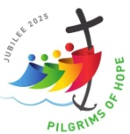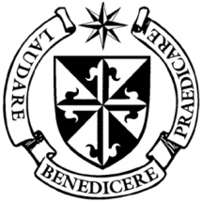

**Dominican Newsletter**

***St. Catherine’s Church, Dominic Street, Newry.***

**4th May 2025** Tel: 028 3026 2178 **3rd Sunday of Easter**

**Masses:**  **Vigil:** Sat 7.30pm, **Sunday**: 8.00am, 9.30am, 11.00am, 12.30pm.

Weekdays: Monday to Saturday: 7.30 am, 11.00 am, 7.30 pm *(Vigil Sat.)*

Confession: Saturday: 11.30am - 12.30pm and 4.00pm – 5.00pm

**Website:** <https://newrydominican.com/> **Facebook**: [www.fb.com/newrydominican](http://www.fb.com/newrydominican)

**Watch live**: newrydominican.com/live **Lectio Centre**: lectio.newrydominican.com

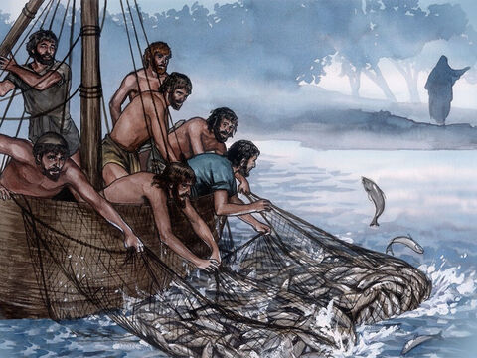**Do you love me?**

Three times Jesus asks Peter if he loves him. Peter gets frustrated with the question being repeated.

It is a question we often ask ourselves, *‘Am I loved’?* It makes a difference to be loved & to feel loved. Love transforms us, love enables peace and happiness to grow. Today we reflect on God’s love for us.

Jesus asks us if we love him.

The Papal Conclave

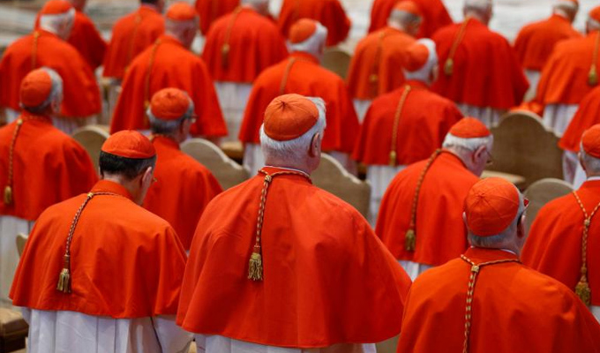

The Papal Conclave has been set for Wednesday May 7th when the Cardinals meet for morning Mass at St. Peter’s Basilica praying to the Holy Spirit for wisdom to choose the next pope.

The Conclave will take place in the Vatican’s Sistine Chapel, which will remain closed to visitors during those days until the new pope is elected - with the appearance of white smoke from the chimney of the Sistine Chapel.

We pray for God’s grace on those voting.

Do we have love for Jesus?

Is He most important in our

lives? How do we express that

love? Do we experience his

love for us? Peter responded:

‘*‘Lord, you know*

everything*;*

*you know I love you,’*

Good Friday Collection for the Holy Land

The amount collected came to £790.43 and will be very welcome in the Holy Land at this difficult time.

Feasts this week

Monday 3rd

Blessed Edmund Rice.

***Queen of the May***

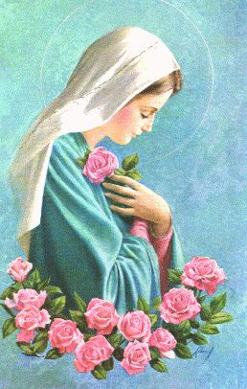

**Bring flow'rs of the fairest,  
Bring blossoms the fairest,  
From garden and woodland  
And hillside and vale;  
Our full hearts are swelling,  
Our Glad voices telling  
The praise of the loveliest  
Rose of the vale.**

*O Mary! we crown thee with blossoms today,  
Queen of the Angels, Queen of the May,  
O Mary! we crown thee with blossoms today,  
Queen of the Angels, Queen of the May.*

**LECTIO EASTER RAFFLE WINNERS**

*The Lectio Easter Raffle took place Easter Week. The following are the results:*

Large Easter Hamper - Maria McKeown

Double Drawer Air Fryer – Elizabeth Rudolph

32”Smart LED TV - Anne Crilly

£100 LIDL Voucher - Eugene Gallagher

Hand Cut Crystal Glasses Set – Orlagh Duggan

Canteen of Cutlery – Kathleen Carnegie

Cordless Mini Vacuum Cleaner – Joe Hutchinson

Sandwich Maker – Caoimhe Connell

Easter Egg Tree – Sharon McLoughlin

Light Up Easter Bunny – Mark Mackin

Easter Basket – Pauline Boyle

Easter Basket with £100 – Mary Meehan

The grand total raised was £1,460.00.

*(£1365 from cash donations and*

*£95.00 from card transactions.)*

*We would like to thank sincerely all who donated prizes for the raffle and all who entered the draw.. The money raised will go towards the running costs of the Dominican Church, Priory*

*and Lectio Centre.*

**Dominican Student Brothers**

Next weekend 10th/11th May, two of our Dominican student brothers **Br. Michael Donohue O.P.**  and **Br. Krsysztof Capucinski O.P.** will be with us in Newry and will speak at Masses about their lives as Dominicans in formation. Next Sunday is Good Shepherd/Vocations Sunday, the Day of Prayer for Vocations. We ask your prayers for Vocations.

Collection for Sunday 27th April was £2,865. *Thank You.*

*We pray for those at the Conclave in Rome*

*that they will be guided by the Holy Spirit*

*as they choose a new Pope. Amen*

*In the Church Mon.- Sat.*

*Morning Prayer 8.15am*

*Evening Prayer 6.00pm*