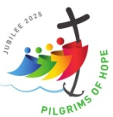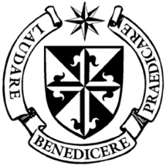

**Dominican Newsletter**

***St. Catherine’s Church, Dominic Street, Newry.***

**25th May 2025** Tel: 028 3026 2178 **6th Sunday of EASTER**

**Masses:**  **Vigil:** Sat 7.30pm, **Sunday**: 8.00am, 9.30am, 11.00am, 12.30pm.

Weekdays: 7.30am, 11.00 am, 7.30 pm *(Vigil Sat.)*

Confession: Saturday: 11.30am - 12.30pm and 4.00pm – 5.00pm

**Website:** <https://newrydominican.com/> **Facebook**: [www.fb.com/newrydominican](http://www.fb.com/newrydominican)

**Watch live**: newrydominican.com/live **Lectio Centre**: lectio.newrydominican.com

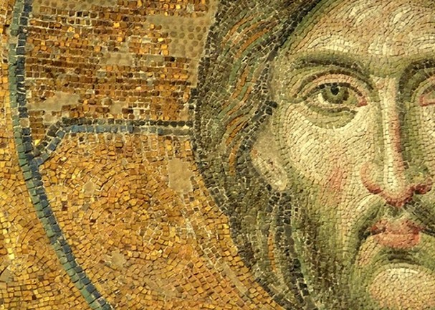

***‘Peace I bequeath to you, my own peace I give you’***

**There is so much talk about peace, we pray all the time for peace, for peace in war torn countries. Peace is at the heart of the Christian message.**

**Pope Leo XIV** greeted the world for the first time on with the words “**Peace be with you all**.” And then he continued: ***‘Dearest brothers and sisters, this is the first greeting of the Risen Christ, the Good Shepherd, who has given his life for God’s flock. I too would like that this greeting of peace will enter into your heart, reaching your families, and all people, wherever they are, to all peoples, to all the earth. Peace be with you****,’*

Jesus in today’s Gospel the **Risen Jesus** greets the people with peace. There is a great need and desire for peace. We are all searching for peace and praying for peace in the world. In his homily last Sunday *(see back page)* Pope Leo XIV appeals for peace in war-torn parts of the world, praying for people who are suffering.

*O Divine Master,  
grant that I may not so much seek to be consoled as to console,  
to be understood as to understand,  
to be loved as to love.  
For it is in giving that we receive,  
it is in pardoning that we are pardoned,  
and it is in dying that we are born to eternal life. Amen.*

## Peace Prayer of St. Francis

*Lord, make me an instrument of your peace:  
where there is hatred, let me sow love;  
where there is injury, pardon;  
where there is doubt,* [*faith*](https://www.biblestudytools.com/topical-verses/bible-verses-for-faith-in-hard-times/)*;  
where there is despair, hope;  
where there is darkness, light;  
where there is sadness, joy.*

**Pope Leo XIV**

***Inauguration Mass***

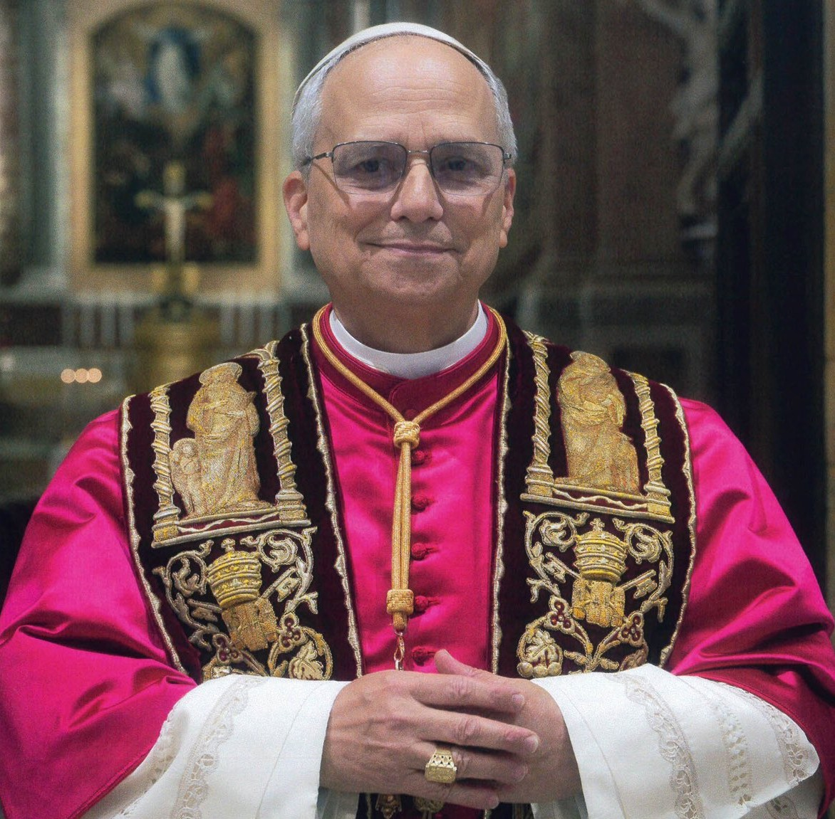

At the conclusion of the Mass of Inauguration of his pontificate on Sunday, Pope Leo XIV prayed the Regina Caeli and appealed for people suffering due to war.

He thanked the **200,000** people and numerous delegations attending the Eucharist, expressing his gratitude to the representatives of nations, Churches, and various religions.

***“In the joy of faith and communion, we cannot forget our brothers and sisters who are suffering because of war,”*** said Pope Leo.

He recalled that ***“the surviving children, families, and elderly”*** in Gaza have been reduced to starvation, as the Israel-Hamas war continues.

In Myanmar, noted the Pope, ***“new hostilities have cut short innocent young lives.”***

And, he lamented, ***“martyred Ukraine awaits negotiations for a just and lasting peace.”***

After the Mass, **Pope Leo XIV** met privately with **Ukrainian President Volodymyr Zelensky,** who attended the Inauguration Mass with his wife.

Pope Leo XIV appeals for peace in war-torn parts of the world, praying for people suffering because of war, especially in ***Gaza, Myanmar, and Ukraine.***

*‘****We cannot forget those suffering due to war’***

Last Week’s Plant Sale

Last week’s plant sale was very successful and brought about great interest in the plants. The amount raised came to £1,077 + €92.

We thank all those who donated plants for the sale and especially the Keenan family for organizing the Fund Raiser.

The winner of the Raffle for the Window Box was Peader Connolly.

Sponsored Walk

*Due to a Concert being held in the Dominican Church in Aid of The Gateway Club on Sunday 15th June in the Sponsored Walk in Aid of the Repairs and Refurbishments of the Church will be held a week earlier on Sunday 8th June 2025, leaving Camlough at 3pm to the Dominican for Refreshments. On Sunday 1st June and Sunday 8th June after each Mass if anyone would like to Sponsor us or maybe take a Sponsor Card and join us in the Walk to help with the badly needed repairs to the Church we would be very grateful.*

Sponsor cards can be collected from the Sacristy or the Lectio Centre.

St Jude - Annual Novena

1st June to Sun. 8th June

Calvary, Omeath Rosminian Fathers

Mass each evening at 7pm

Healing Mass Sun 8th Jun.7pm

Preacher: Fr Jimmy Brown I.C.

Everyone welcome

The Collection for last Sunday 18th May was £2,736. *Thank You!*