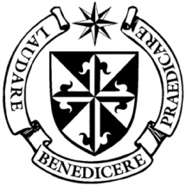

**Dominican Newsletter**

***St. Catherine’s Church, Dominic Street, Newry.***

**11th May 2025** Tel: 028 3026 2178 **4th Sunday of EASTER**

**Masses:**  **Vigil:** Sat 7.30pm, **Sunday**: 8.00am, 9.30am, 11.00am, 12.30pm.

Weekdays: Easter Week: (NO 7.30am Mass) 11.00 am, 7.30 pm *(Vigil Sat.)*

Confession: Saturday: 11.30am - 12.30pm and 4.00pm – 5.00pm

**Website:** <https://newrydominican.com/> **Facebook**: [www.fb.com/newrydominican](http://www.fb.com/newrydominican)

**Watch live**: newrydominican.com/live **Lectio Centre**: lectio.newrydominican.com

**Habemus Papam!**

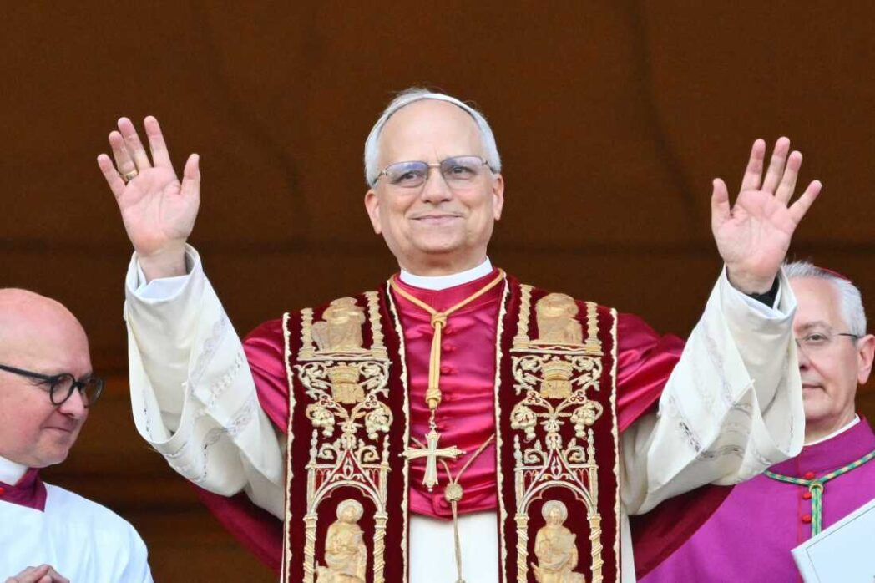

Our new Pope - Pope Leo XIV

We rejoice in the election of Pope Leo XIV. Robert Francis Prevost (69) was born in Chicago U.S.A. in 1955. He joined the Augustinian Order and was ordained priest in 1982. He has two older brothers, Louis and John. He spent much of his career as a missionary in Peru - South America before becoming prior general of the Augustinian Order. He became Bishop of Chiclayo in Peru in 2015. He has dual citizenship of U.S.A. and Peru. In 2023 he became a cardinal and has been working in Rome responsible for the Office in charge of Bishop Appointments. Our prayers go with Pope Leo XIV as he begins his ministry.

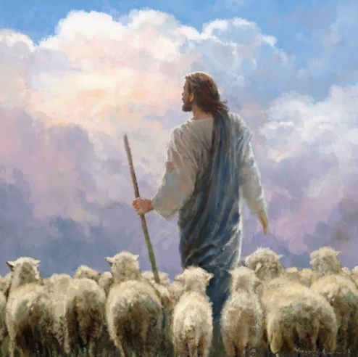***‘The sheep that***

***belong to me***

***listen to my voice;  
I know them***

***and they follow me’***

*Today is World Day of Prayer for Vocations and two of our Dominican student brothers will speak at Masses on their own vocations. There are those who feel the call to serve God in different ways. Our prayer is that we will follow God’s will in whatever he asks of us.*

*Jesus reminds us in the Gospel today that he is the shepherd who cares for us. We too are called to be shepherds to those around us.*

*Pope Leo, our new pope, has now become a shepherd to us as we look to him for teaching and guidance in our following of the Gospel.*

Renovation Fund

Sponsored Walk

Sunday 15th June 3.00pm

*After last year’s successful walk, another walk will take place this year on 15th June.*

*Sponsor Cards will be available after Masses on 8th June and on the morning of the Walk on 15th June.*

Open Day

*There will be an Open Day on Saturday 24th May from 10.00am to 1.00pm in the Dominican Priory Tallaght, Dublin for anyone who might be interested in studying Theology and Philosophy with the Dominicans. There is a variety of courses for all tastes.*

*Phone Pat at 077 360 428 40 for details.*

.

**Guided tours of Newry Cathedral**

  This year, 2025, marks the **bicentenary** of the laying of Newry Cathedral's foundation stone on June 8th, 1825. To celebrate this significant milestone, guided tours of the Cathedral will take place on the following dates:

 Wednesday 11th June at 6.45pm,  Wednesday 25th June at 2.00pm, Wednesday 9th July at 6.45pm, Wednesday 23rd July at 2.00pm, Wednesday 6th August at 6.45pm Wednesday 20th August at 2.00pm

‘THE CHOSEN’

Faith – Film & Fellowship

For Young Adults 18-35

Join us weekly to watch the series ‘THE CHOSEN’ and discuss our faith.

Dominican Hall 5.30pm

Bring your own snacks

The Collection for Sunday 4th May

was £3,035. *Thank You!*