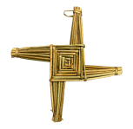

**Dominican Newsletter**

***St. Catherine’s Church, Dominic Street, Newry.***

**13th April 2025** Tel: 028 3026 2178 **PALM SUNDAY**

**Masses:**  **Vigil:** Sat 7.30pm, **Sunday**: 8.00am, 9.30am, 11.00am, 12.30pm.

Weekdays: Monday to Saturday: 7.30 am, 11.00 am, 7.30 pm *(Vigil Sat.)*

Confession: Saturday: 11.30am - 12.30pm and 4.00pm – 5.00pm

**Website:** <https://newrydominican.com/> **Facebook**: [www.fb.com/newrydominican](http://www.fb.com/newrydominican)

**Watch live**: newrydominican.com/live **Lectio Centre**: lectio.newrydominican.com

HOLY WEEK 2025

PALM SUMDAY

Today we enter into Holy Week / Passion Week, the days leading up to Easter. We begin with Palm Sunday, the triumphal entry of Jesus into Jerusalem with the people waving palms. The scene changes later in the week with the condemnation of Jesus, his crucifixion and death.

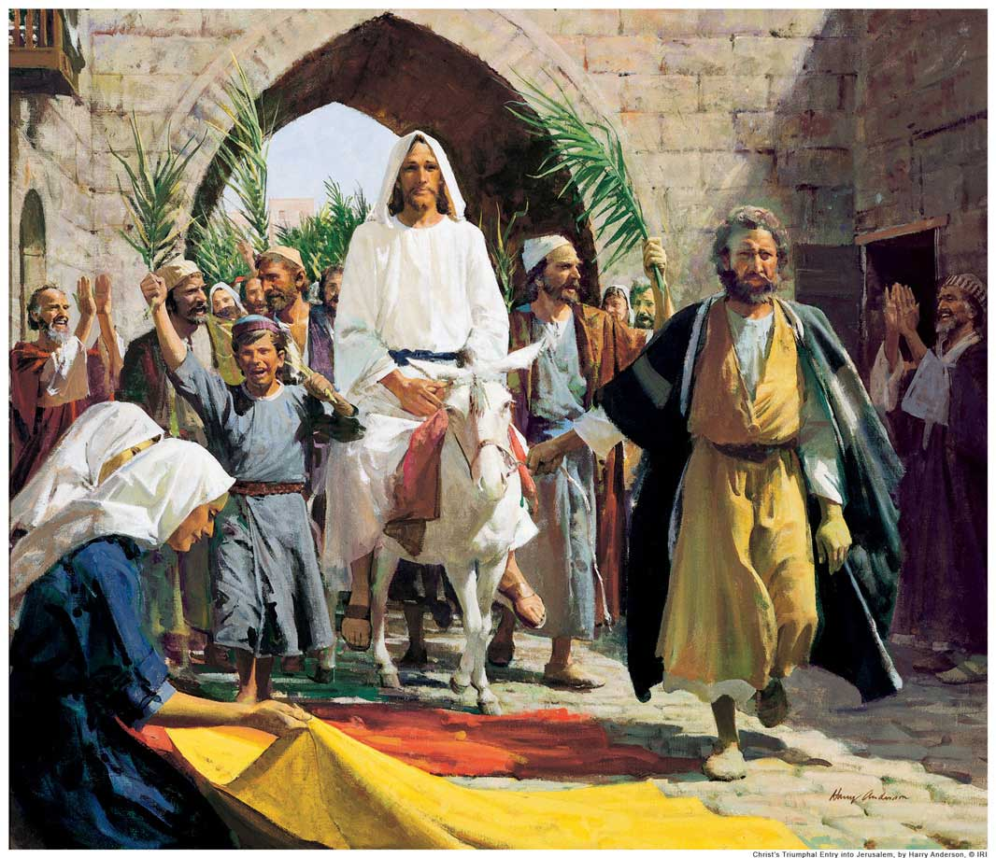

It is a time for us to be with Jesus on his journey through Holy Week and to witness his suffering and death out of his love for us.

We are the ones waving the palms for Jesus but when temptation comes we drop the palms and become like the people who turned away from God. We get caught up with sin which tears us away from Jesus.

But today Palm Sunday we celebrate the arrival of Jesus and sing Hosanna!

*Palms will be blessed*

*and distributed at all Masses*

Mon. Tues.Wed. Masses as usual

Confessions: 11.30 – 12 noon

HOLY THURSDAY

*No Morning Masses*

5.30pm Childrens’ Mass

7.30pm Mass of the Lord’s Supper

GOOD FRIDAY

11.00am

Childrens’ Stations of the Cross

3.00pm

Celebration of the

Lord’s Passion

*(followed by Confessions)*

7.30pm Stations of The Cross

8.00pm TAIZE

Prayer around the Cross

HOLY SATRUDAY

Confessions

11 – 1.00 & 4.00 – 5.00pm

9.00pm Easter Vigil

EASTER SUNDAY

Masses: 8.00a.m., 9.30am, 11.00am,& 12.30pm

Easter Flowers

*Donations of flowers for the Church for Easter and for the Easter Garden will be very welcome. Flowers can be left in later in the week.* *Thank you!*

Holy Thursday

10.30am

CHRISM MASS

NEWRY CATHEDRAL

A*rchbishop Eamon Martin, along with the clergy of the Diocese, will celebrate the Chrism Mass on Thursday 17th April*

*at 10.30am in Newry Cathedral.*

*All are welcome.  In particular, an invitation to attend is extended to families and schools in the diocese with children who will make their Confirmation this year.  The Mass is also available  via Newry Cathedral Parish webcam at*

[*www.newrycathedralparish.org*](http://www.newrycathedralparish.org/)

Pre-Baptism Meeting

Pre-Baptism Meeting for parents and godparents, takes place in Newry Parish Centre on Wednesday 17th April at 7.30p.m

Pope Francis and Holy Week

Due to his recent illness Pope Francis is not scheduled to attend events during Holy Week/Easter and nothing has been confirmed as to when or where he might be present. It is hoped that he would give the Urbi et Orbi blessing on Easter Sunday morning as it cannot be delegated to anyone else, or that he may impart the blessing on a different format such as live-stream video.

The Vatican has not yet confirmed who will preside as main celebrant at the Easter liturgies.

Easter Mass Bouquets

Easter Mass Bouquets are now available in the Lectio Office.

The intentions will be remembered in the Masses and Prayers over the Octave of Easter

EASTER RAFFLE (Holy Thursday)

*£5 a line for the Draw*

*Now in the Lectio Office.*

*Lots of Great Prizes to be won!*

Proceeds go towards supporting Church, Priory and Lectio Centre.

New Archbishop of Liverpool

His Holiness Pope Francis has appointed Bishop John Sherrington as Archbishop of Liverpool.

Archbishop-elect Sherrington will become the tenth Archbishop of Liverpool in succession to Dominican Archbishop Malcolm McMahon OP, who has been Archbishop of Liverpool since 2014.

St. Catherine’s Church

150 years

*This year we celebrate the 150th Anniversary of St. Catherine’s Church on 17th October.*

*It will be a big occasion for us and a number of events are being planned for the 150th* The Church was opened in 1875.

Collection for Sunday 6th April

£2,851 *Thank You!*