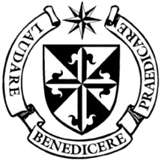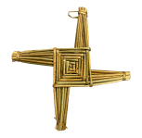

**Dominican Newsletter**

***St. Catherine’s Church, Dominic Street, Newry.***

**30th March 2025** Tel: 028 3026 2178 **Laetare Sunday**

**Masses:**  **Vigil:** Sat 7.30pm, **Sunday**: 8.00am, 9.30am, 11.00am, 12.30pm.

Weekdays: Monday to Saturday: 7.30 am, 11.00 am, 7.30 pm *(Vigil Sat.)*

Confession: Saturday: 11.30am - 12.30pm and 4.00pm – 5.00pm

**Website:** <https://newrydominican.com/> **Facebook**: [www.fb.com/newrydominican](http://www.fb.com/newrydominican)

**Watch live**: newrydominican.com/live **Lectio Centre**: lectio.newrydominican.com



*We send our best wishes to all Mothers today and ask God’s blessings upon them!*

In the Gospel of today we see the father welcoming back the prodigal son who had gone astray. God is like that father, filled with compassion and always willing to forgive.

Today – Mother’s Day we remember the love of mothers for their children. Like the Father in the Gospel we see the love of Mother’s for their children.

We pray for all mothers, that they may be good Mothers filled with compassion and love for their children bringing them up in the faith.

We ask Our Lady the Mother of Jesus to intercede for all mothers especially mothers struggling in their role as mothers.

***Mothers***



***Grandmothers***



***Expectant Mothers***

***and Godmothers!*** 

Easter Mass Bouquets

Easter Mass Cards are now available in the Lectio Office.

The intentions will be remembered in the Masses and Prayers over the Octave of Easter.

Mobile Phones

*Please put your phones into ‘Silent’ while in the Church and during Mass. Thank you.*

STATIONS OF THE CROSS

Friday after 11 am Mass

Friday 4th April - First Friday

*Saturday 5th April:*

Feast of St. Vincent Ferrer O.P.

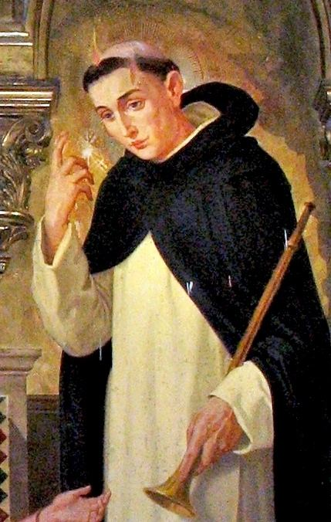

St. Vincent Ferrer born in 1357 grew up in Valencia in Spain. He joined the Dominican Order in Valencia and specialised in Philosophy but his main focus was on preaching. He was appointed the Pope’s theologian. He became a famous preacher in Europe in 14th cent. at a time when there was great division in the Church.

St. Vincent with his preaching brought many into the Church.

St. Vincent Ferrer died on April 5 1419 aged 62.

He was canonised in 1455.

Forgiveness

(*Today’s Gospel) Luke 15: 1-3, 11-32)*

We see in today’s story of the Father forgiving his son who went away and squandered his money.



At the heart of the Gospel is the forgiveness. We see the forgiveness of God in today’s Gospel and especially in the Sacrament of Reconciliation.

We can find it hard to forgive, hard to let go of hurt.

We become free when we are able to let go through forgiveness.

Forgiveness begins with ourselves. We can be our own worst enemies, we can be hard on ourselves, critical of what and how we do things. When we can forgive ourselves it is easier for us to forgive others.



EASTER RAFFLE

*Tickets for Easter Raffle are now available at the Lectio Office.*

*Lots of Great Prizes to be won!*

Proceeds go towards supporting Church, Priory and Lectio Centre.

Dromore Diocese

Pilgrimage to Lourdes

Monday 9th 14th June 2025

Cost: £850pp *(full board)*

*Contact Sean O’Gorman 028 302 637 39*

1st Sunday Childrens’ Liturgy 11.00am Massl

Primary School Children

Collection for Sunday 23rd February was £2,976.  *Thank you!*