

**Dominican Newsletter**

***St. Catherine’s Church, Dominic Street, Newry.***

**23rd March 2025** Tel: 028 3026 2178 **3rd Sunday of Lent**

**Masses:**  **Vigil:** Sat 7.30pm, **Sunday**: 8.00am, 9.30am, 11.00am, 12.30pm.

Weekdays: Monday to Saturday: 7.30 am, 11.00 am, 7.30 pm *(Vigil Sat.)*

Confession: Saturday: 11.30am - 12.30pm and 4.00pm – 5.00pm

**Website:** <https://newrydominican.com/> **Facebook**: [www.fb.com/newrydominican](http://www.fb.com/newrydominican)

**Watch live**: newrydominican.com/live **Lectio Centre**: lectio.newrydominican.com

Easter Mass Bouquets

Easter Mass Cards are now available in the Lectio Office.

The intentions will be remembered in the Masses and Prayers over the Octave of Easter.

A Fig Tree

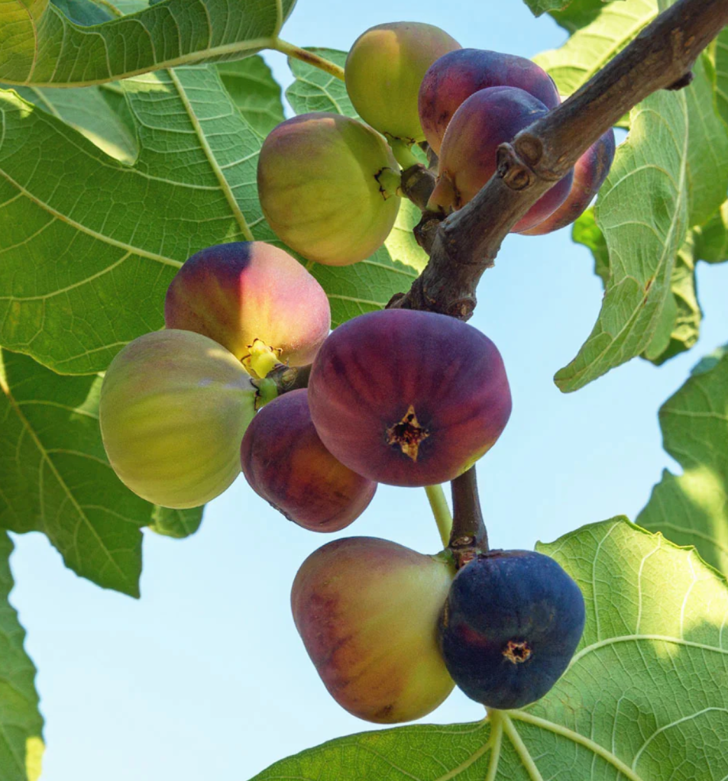Figs are very nutricious and are a good source of food containing many nutrients. In Biblical times figs had an important role in feeding the people with was regarded as a healthy food..

Jesus tells the story of fig trees in today’s Gospel. They are planted to provide fruit for food but if they produce no fruit they are of no good. In the parable of the fig tree that produced no fruit the landowner instructed his assistant to cut it down, but the assistant appealed to give it a chance for another year to see if it improved.

The God we believe in is a God who does not write us off but like the assistant gives us a chance to redeem ourselves. Lent is that time when we try to make things right and try to live better lives, and produce fruit that will last.

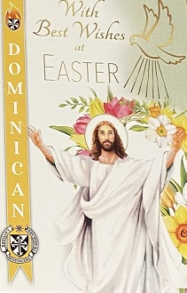

EASTER RAFFLE

*Tickets for Easter Raffle are now available at the Lectio Office.*

*Lots of Great Prizes to be won!*

Proceeds go towards supporting Church, Priory and Lectio Centre.

*Free Parking at the Buttercrane Centre for Mass attendees until 1.30pm on Sundays*

*Car Parking:* *Please do not park your car in front of the gate at the Lectio Centre. Access is always needed by the residents. Thank you.*

Mobile Phones: *Please switch off in Church and during Mass.*

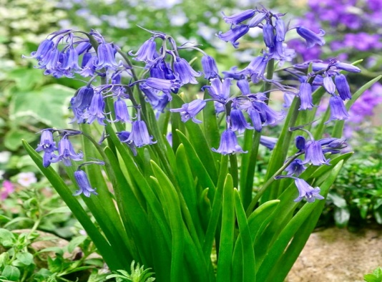

**Thoughts During Lent .......**

**by Blessed Carlo Acutis**

*“Our soul is like a hot-air balloon.*

*If by chance there is a mortal sin, the soul falls to the ground. Confession is like the fire underneath the balloon enabling the soul to rise again. ... It is important to go to confession often”* Carlo Acutis**’**  Canonisationwill take place in Rome on 27th April

*Bluebells*

Fr. Benedict Hegarty O.P.

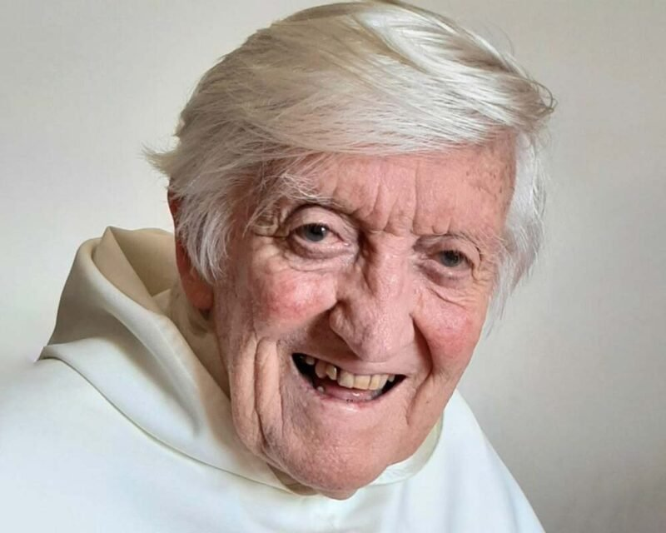

*Fr Benedict Hegarty O.P. died on Wednesday in Cork. Many years ago he was prior of St. Catherine’s Dominican Church & Priory in Newry and will be remembered by many. He taught Scripture for many years in Tallaght, Dublin and throughout the country.*

*He was a native of Cork.*

*In recent years he was assigned to the Dominican Retreat house in Cork. May he Rest in Peace.*

*Monday to Saturday*

*8.00am Morning Prayer (Lauds)*

*6.00pm Evening Prayer (Vespers)*

**Pope Francis**

On Wednesday morning the Pope concelebrated Mass for the Feast of Saint Joseph in the chapel on the 10th floor of Gemelli Hospital.

He spent the rest of the day alternating between his various therapies, prayer and some work activities.

As Pope Francis marks 33 days in Rome’s Gemelli Hospital fighting double pneumonia, the official medical information provided to journalists has become less detailed and less frequent, which in this case would appear a positive sign.

In a March 19 statement, the Vatican said that the Pope’s clinical status “continues to improve”. The statement confirmed that doctors have “suspended non-invasive mechanical ventilation” – when an oxygen mask is tightly sealed over the nose and mouth – for the Pope and that he has also reduced his use of high-flow oxygen through nasal cannula tubes.

Meanwhile, he continues to undergo and show improvement in motor and respiratory therapy, the Vatican said.

Doctors at the hospital, according to the Holy See Press Office, believe that the Pope’s respiratory infection is “under control”, though it has not been completely eliminated, while his blood tests are all normal and he continues to have no fever.

Dromore Diocese

Pilgrimage to Lourdes

Monday 9th 14th June 2025

Cost: £850pp *(full board)*

*Contact Sean Gorman 028 302 637 39*

*or Fr. Adrian Farrelly O.P.*

**STANTON HEALTHCARE**

*The team at Stanton Healthcare Belfast extends its heartfelt gratitude for the generous support from the People of Newry The total collected from the Churches in Newry came to* ***£3,828.63.***

*Your contributions will truly make a lasting impact on the lives of mothers, their babies, and future generations. We sincerely thank you for being a part of this important work.*

Collection for Sunday  *16th March was £2,945.*  *Thank you!*