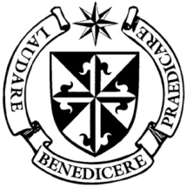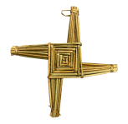

**Dominican Newsletter**

***St. Catherine’s Church, Dominic Street, Newry.***

**16th February 2025** Tel: 028 3026 2178 **6th Sunday Year C**

**Masses:**  **Vigil:** Sat 7.30pm, **Sunday**: 8.00am, 9.30am, 11.00am, 12.30pm.

Weekdays: Monday to Saturday: 7.30 am, 11.00 am, 7.30 pm *(Vigil Sat.)*

Confession: Saturday: 11.30am - 12.30pm and 4.00pm – 5.00pm

**Website:** <https://newrydominican.com/> **Facebook**: [www.fb.com/newrydominican](http://www.fb.com/newrydominican)

**Watch live**: newrydominican.com/live **Lectio Centre**: lectio.newrydominican.com

Jesus teaches the disciples

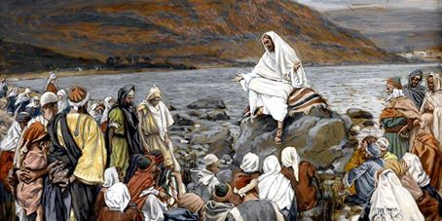

Jesus is showing the way that leads to happiness.

Real happiness is not always found in the things we think will make us happy but very often in carrying our own crosses and we see how close we are to to God and to Jesus who endured rejection and suffering in his life.

A the end of today’s Gospel Jesus says:

*‘Rejoice when that day comes and dance for joy, for then your reward will be great in heaven’.*

In this Holy Year let us have HOPE, hope in difficult times, hope in our pain and struggles. With faith in God we have every reason to be people who will always have hope.

***The importance of music***

***in creating peace***

Pope Francis

At the Annual Italian Music Festival, Sanremo, Pope Francis called the attention to the important role music has in creating world peace.

The Pope said ***‘Music is a language that speaks to all , that all peoples, in different ways, speak, and it reaches the heart of everyone. Music can help the coexistence of peoples.”***

Israeli singer Noa and Palestinian singer Mira Awad performed a duet in Hebrew, Arabic, and English to the tune of **"Imagine" by John Lennon.**

Calling attention to the violence around the world, Pope Francis addressed the reality that there are*“****many children who cannot sing,”*** not because they cannot hold a tune but because they ***“cry and suffer from the many injustices in the world, from the many wars, and situations of conflict.”***

**“*Wars destroy children,” “to see those who have hated each other ‘shake hands, embrace, and say with life, music, and song: peace is possible!”.***

**St. Teresa of Calcutta**

**Feast 5th September**

The Vatican has

announced that in the

Church the ***Feast of St.***

***Teresa of Calcutta*** will be

celebrated as an optional

liturgical memorial

annually on **September 5,** the date of her death in 1997.

400th Anniversary of the Birth of St. Oliver Plunkett

Saint Oliver Plunkett 400th Anniversary was celebrated at a service of prayer, reflection and celebration in Saint Peter’s Jubilee Church, Drogheda, Co Louth, Archdiocese of Armagh, on 12 February.

to t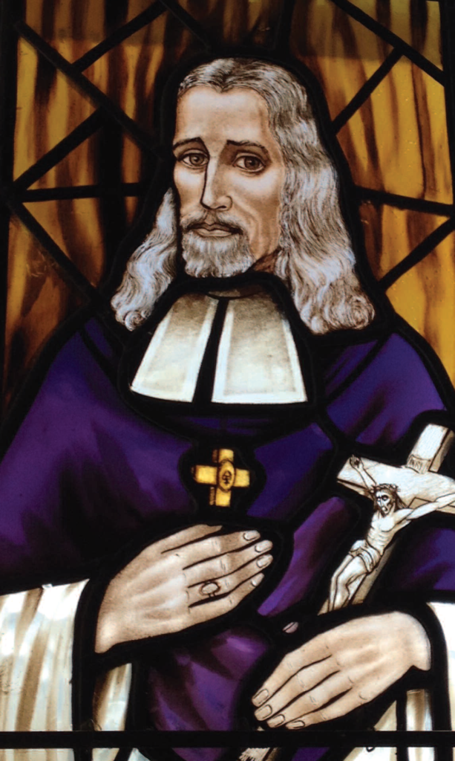he people who were sick and dying in his community.  e died at the young adult age of 24 while in charitable service to the people who were sick and dying in his community.

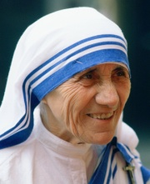

‘Journeying with the

Sunday Gospels

For the season of Lent’

An introduction to Lectio Divina commences Saturday 8th March

10.30- 11.30am for six Saturdays.

If you are interested in journeying prayerfully, meditatively and reflectively on the Sunday Gospels you are welcome to come alone.

For booking contact:

Lectio Centre, Dominic St., Newry.

Monday to Friday 10am to 5pm

Tel 028n302 62178

Email: lectiocentre35@gmail.com

Baptisms

The next Pre-Baptism Meeting  for parents and godparents takes place in Ne*w*ry Parish Centre on Wednesday 19th February  at 7.30p.m.

Pope Francis to visit Dominicans in Rome

*Pope Francis will begin Ash Wednesday by visiting the headquarters of the Dominican Order at Santa Sabina in Rome celebrating Mass with the distribution of ashes. It is traditional for the Pope to begin Lent with Mass at the Dominican Basilica of Santa Sabina in Rome.*

Growth of Church in South Korea

*The Archdiocese of Seoul in South Korea has now reached 1,000 priests, upon ordaining 26 new priests on Febuary 7th.*

*South Korea will host the next World Youth Day in 2027,*

Collection for Sunday 9th February

was £,3135 *Thank you!*