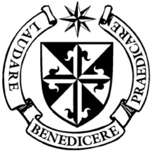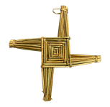

**Dominican Newsletter**

***St. Catherine’s Church, Dominic Street, Newry.***

**19th January 2025** Tel: 028 3026 2178 **Catholic Schools Week**

**Masses:**  **Vigil:** Sat 7.30pm, **Sunday**: 8.00am, 9.30am, 11.00am, 12.30pm.

Weekdays: Monday to Saturday: 7.30 am, 11.00 am, 7.30 pm *(Vigil Sat.)*

Confession: Saturday: 11.30am - 12.30pm and 4.00pm – 5.00pm

**Website:** <https://newrydominican.com/> **Facebook**: [www.fb.com/newrydominican](http://www.fb.com/newrydominican)

**Watch live**: newrydominican.com/live **Lectio Centre**: lectio.newrydominican.com

Church Unity Week

Newry Inter Church Forum Invites us to a to a Church Unity Service at Methodist Church,

Sandy’s Street

7.00pm

Tuesday 21st January.

*All will be welcome to this important Church Unity event.*

Water into Wine

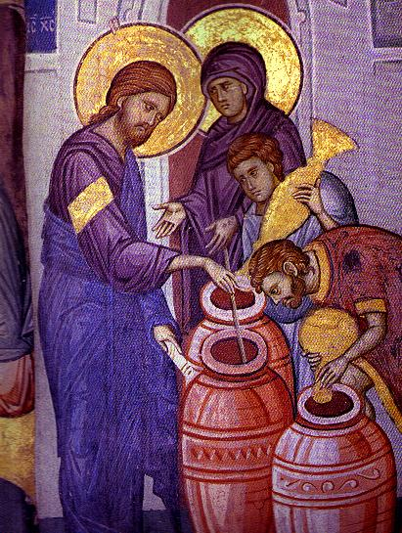

As Jesus begins his ministry he performs his first miracle at the wedding feast at Cana. Mary, the Mother of Jesus, was happy for the newly married couple but when they ran out of wine for the wedding feast she persuaded her son to help them. Mary was inspirational in Jesus performing his first miracle.

Mary is there for us when we might lack confidence in ourselves, she encourages us and affirms us in our Christian duty. She wants us to be witnesses to the power God’s grace through Jesus.

Pilgrimage to Lourdes

The Dromore Diocesan Pilgrimage to Lourdes this year will take place from 9th to 14th June.

Fr. Adrian O.P. will represent the Dominicans and is always happy to see members of the Dominican congregation on the pilgrimage.

Jubilee Year 2025

*‘Jubilee is a time of giving thanks for the providence of the Lord and the fruits of the harvest.*

*‘Jubilee is a time of celebration, a time of singing, sounding of trumpets, an expression of praise to God’.*

*‘Jubilee is a time of looking back in gratitude ‘. Pope Francis*

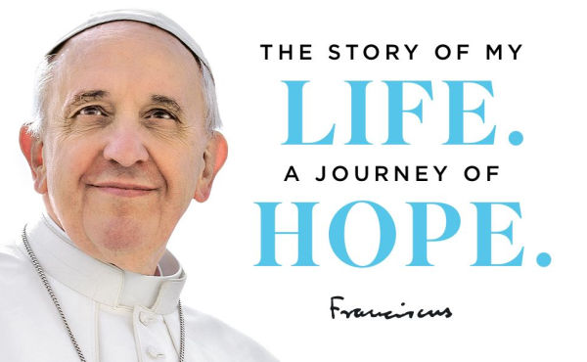

The new book – An Autobiography of Pope Francis was released during the week and is available online and at bookstores.

Pope Francis originally intended this book to appear only after his death, but the needs of our times and the 2025 Jubilee Year of Hope have moved him to make it available now

Written over six years, this complete autobiography starts in the early years of the twentieth century, with Pope Francis’s Italian roots and his ancestors’ courageous migration to Latin America, continuing through his childhood, his youth, his vocation, his adult life, and the whole of his papacy up to the present day.



Fr. Brian Kavanagh will join us next weekend and will celebrate the 12.30pm Mass and speak to us about the charity ALMAS.

*24 ‘Almas is a charity established since October 2003 and was originally set up to support people responding to the painful reality of children who are hiv-positive and suffering with the aids virus.*

*Soon after the charity was established Fr. Brian was out in Ethiopia and witnessed small children living in absolute poverty and so from then on the Charity seeks to help children who are living in and suffering from poverty and whose families are affected by Hiv-Aids.*

*The Friends of ALMAS including the congregation at the Dominican Church in Newry and all who support the fund raising events have made this amazing difference possible’.*

Next weekend the Church Door Collection will be for ALMAS

24 while in charitable service to the people who were sick and dying in his community.

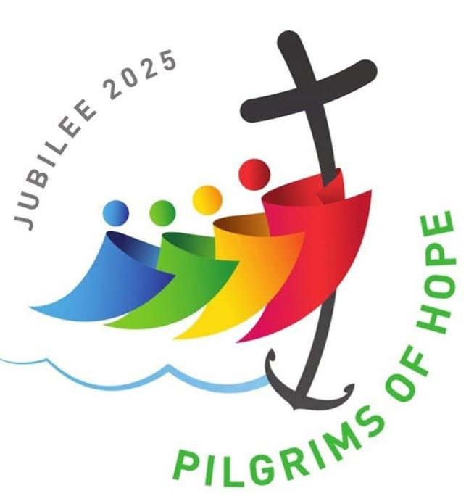

Church Collection

Sunday 12 January

came to £2,720 *Thank You!*

*Feel free to take away*

*Newsletters for others*

*and for the housebound.*