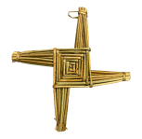

**Dominican Newsletter**

***St. Catherine’s Church, Dominic Street, Newry.***

**13th December 2024** Tel: 028 3026 2178 **3rd Sunday of Advent**

**Masses:**  **Vigil:** Sat 7.30pm, **Sunday**: 8.00am, 9.30am, 11.00am, 12.30pm.

Weekdays: Monday to Saturday: 7.30 am, 11.00 am, 7.30 pm *(Vigil Sat.)*

Confession: Saturday: 11.30am - 12.30pm and 4.00pm – 5.00pm

**Website:** <https://newrydominican.com/> **Facebook**: [www.fb.com/newrydominican](http://www.fb.com/newrydominican)

**Watch live**: newrydominican.com/live **Lectio Centre**: lectio.newrydominican.com

Third Sunday of Advent

This Third Sunday of Advent is also called *GAUDETE SUNDAY.* ‘Gaudete’ meaning Joy. As we prepare to celebrate the birth of the Messiah we are called to be a people of Hope and Joy. The vestments are Rose coloured as is the candle on the Advent Wreath reflecting joy and hope as we look forward to the Birth of Christ.

As Christians we are called to be hopeful, positive and be a people of hope and joy because we are saved with the coming of Christ.

We live in a world where many are affected by negativity and pessimism and we can end up depressed. The coming of Christ is Good News and the reason for us to be a people hopeful and joyful and positive in our daily lives.

We celebrate the coming of Christ as the Prince of Peace and his peace is with us throughout life. May we share that Good News with those around us and help them to celebrate his coming.

JUBILEE YEAR OF HOPE

*‘Pilgrims of Hope’*



The Jubilee Year for 2025 will begin in Rome on the Vigil of the Lord’s Nativity, ****December 24, 2024****, and in local dioceses on Holy Family Sunday, December 29.

As the Church begins a Holy Year *Archbishop Martin will celebrate the Vigil Mass on Saturday 28th December In Newry Cathedral at 6.00pm.* He is asking that a family represents each parish in the Diocese

The Archbishop is also issuing a Pastoral Letter to be read at all Masses that weekend to announce the Jubilee year of Hope.

Please be careful... *We ask those entering and leaving the Church or Priory during the winter months to please be careful in the cold weather as frost and ice can come suddenly and can be dangerous to walk on. Where you can please use the handrails for protection. Thank you.*

*Tea/Coffee available in Dominican Hall after 11am Mass Mondays*

Times have changed for Morning and Evening Prayer in the Church:

Morning Prayer 8.00am

Evening Prayer 6.00pm

*(Morning & Evening Prayer will not be streamlined on the internet)*

**Three New Dominican Cardinals**

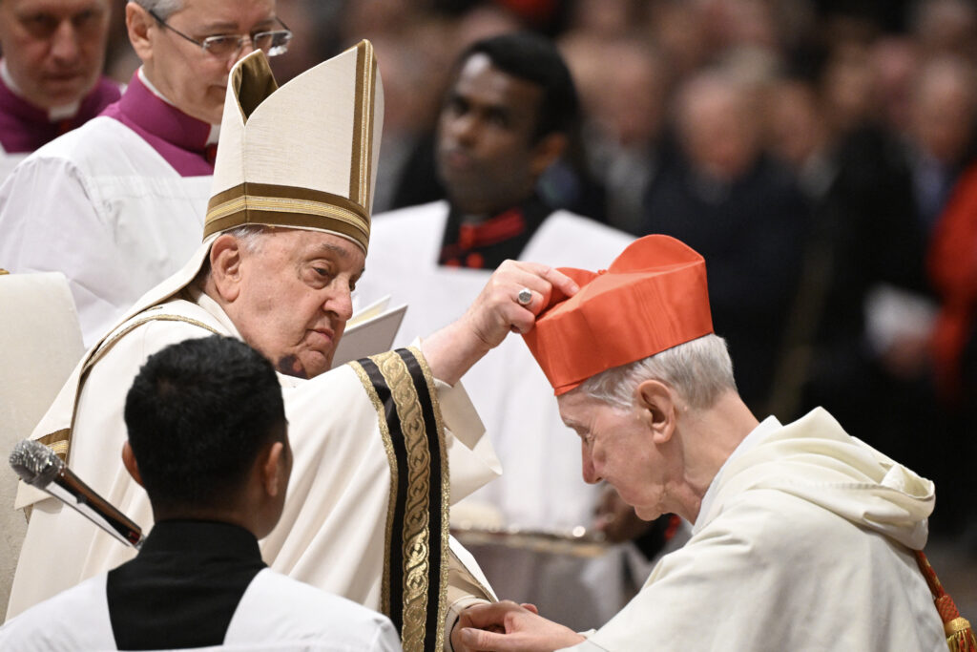

Fr. Timothy Ratcliffe receiving the red hat.

On December 7, Pope Francis elevated 21 new Cardinals, and three of them are Dominicans: Timothy Peter Joseph Radcliffe, OP, a renowned theologian residing in Oxford, England; Jean-Paul Vesco, OP, Archbishop of Algiers, Algeria; and Frank Leo, OP, Archbishop of Toronto, Canada, a member of the Priestly Fraternity of St. Dominic.

Cardinal Radcliffe was Master of the Order some years back and has been a regular visitor to the Dominicans in Ireland.

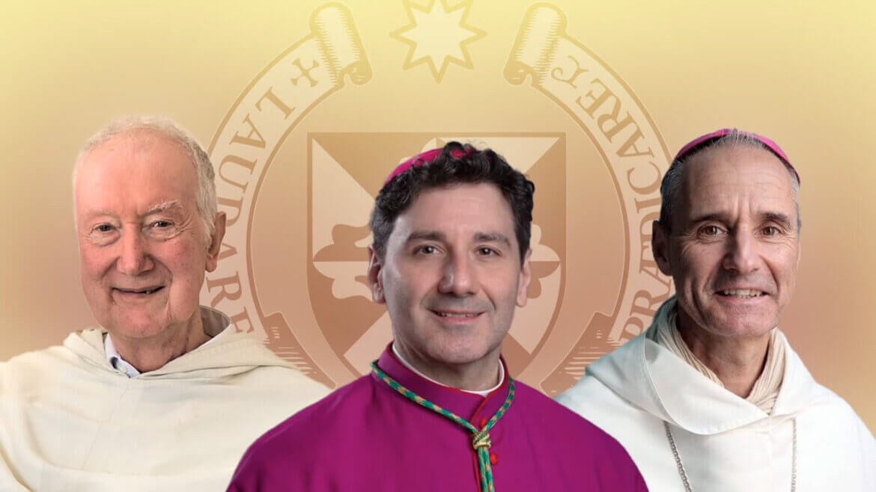

Cardinal Timothy Radcliffe O.P. Oxford

Cardinal Frank Leo O.P. Toronto

Cardinal Jean Paul Vesco O.P. Algeria



Advent Talks

Over the past few years *EWTN Catholic TV* have been broadcasting talks from the Dominican Church in Newry during Advent.

The Talks can be viewed on you tube

[EWTN Ireland - YouTube](https://www.youtube.com/channel/UCK1vbEuW6UcdUj6sIoVO7xQ/videos) videos

Reopening of Notre Dame Cathedral in Paris

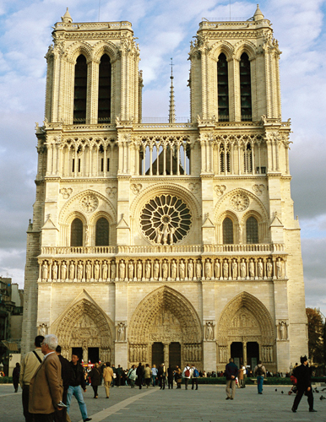

Archbishop Eamon Martin represented the Irish Bishops and people of Ireland at the reopening of Notre dame Cathedral in Paris.

Archbishop Martin said *“I thank God for those who helped save this 850-year-old cathedral from total destruction, and to all those who have helped to restore it.’*

Last Sunday’s Collection

Sunday 17th November was £2,585.

--

Prior Provincial  
Province of India









To:​You​

Mon 28/10/2024 22:10

Hi Adrian

The collection for Sunday 27th October was £2935









To:​You​

Mon 28/10/2024 22:10

Hi Adrian

The collection for Sunday 27th October was £2935