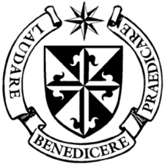

**Dominican Newsletter**

***St. Catherine’s Church, Dominic Street, Newry.***

**17th November 2024** Tel: 028 3026 2178 **33rd Sunday - Year B**

**Masses:**  **Vigil:** Sat 7.30pm, **Sunday**: 8.00am, 9.30am, 11.00am, 12.30pm.

Weekdays: Monday to Saturday: 7.30 am, 11.00 am, 7.30 pm *(Vigil Sat.)*

Confession: Saturday: 11.30am - 12.30pm and 4.00pm – 5.00pm

**Website:** <https://newrydominican.com/> **Facebook**: [www.fb.com/newrydominican](http://www.fb.com/newrydominican)

**Watch live**: newrydominican.com/live **Lectio Centre**: lectio.newrydominican.com

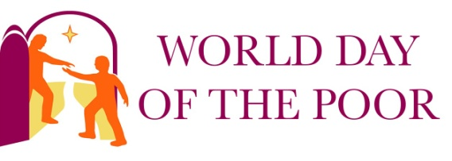

‘THE END’

*Those words* ‘THE END’ *remind me of going to the cinema in my early years and seeing those words appear at the end of a movie.*

*Now we are reminded in today’s Gospel of the ‘end of time’.*

*How will the end it be for us? When will it happen? What will it be like for us? November reminds us of the last days.*

‘Stay awake and stand ready, because you do not know the hour when the Son of Man is coming’

*We also think during November of those who have died, we pray for them, we remember them in Mass. We pray for the Holy Souls, those who are on their way to Heaven but are not there yet. Our prayers can help them on their way.*

*During November many visit the graves of those who have died and pray for them.*

*‘May their souls and the souls of the all faithful departed , theough the mercy of God rest in peace. Amen.’*

Pope Francis in this ***8th World Day of the Poor*** reminds us that the poor have an important part in the **Jubilee of Prayer for 2025.** **“*The prayer of the poor***

***rises up to God***(cf. *Sir* 21:5)”.

The Pope reiterates that the poor have a privileged place in the heart of God, who is attentive and close to each one of them. God listens to the prayer of the poor and, faced with their suffering, becomes “impatient” until he has rendered justice to them speedily” (21:5).

Today the Pope will have lunch with the poor in the Paul VI Hall in Rome.

In his *Message for the Poor*, Pope Francis invites everyone to learn to pray for the poor and to pray together with them.

The *World Day of the Poor* is an opportunity to become aware of the presence of the poor in our cities and communities, and to understand their needs.

***‘Let us not forget, however, the many people who in our cities continue to devote a great deal of their own time to listening and supporting the poorest’.***

Pre- Baptism Meeting

The next Pre-Baptism Meeting  for parents and godparents takes place in Newry Parish Centre on Wednesday 20th of November  at 7.30p.m.

Monday Morning Tea/Coffee ...will resume tomorrow Monday 18th. in the Dominican Hall after 11.00am Mass on Mondays

Divine Mercy Day Retreat

at Cuan Mhuire *200 Dublin Road Newry*

Saturday 23rd November

Registration 9.30am

Retreat 10am to 5.30pm *Mass at 4.30pm*

Preacher: Fr. Tony Devlin

Please bring packed lunch

(Tea/Coffee available)

Bookings to : Eileen 028 302 68751

or Liz at 028 302 65279

**St. Martin Novena**

*Thanks to all who participated in the Novena this year. A special thanks to all who provided music, to Readers and Eucharist Ministers. Collectors,**those who sold the St. Martin Candles* ***and*** *Novena merchandise,**and to the Lectio Centre members who sold St. Martin merchandise.*

*Thanks to those who helped in the preparations for the novena, a lot of work had to be done making sure everything was ready.*

*A very special thanks to* ***Fr. Tom McCarthy O.P.*** *our preacher who came from our Dominican Priory at the Claddagh in Galway for the Novena.*

Dementia NI

There are people we know with Dementia here in Northern Ireland and there are *‘Empowerment Groups’* to provide assistance about to live and to help those with dementia.

There is an Empowerment Group which meets in Newry and they offer advice on what they do and on Local services available. They can be contacted at:

[www.dementiani.org](http://www.dementiani.org)

Email: infodementiani.prg

Tel: 028 969 31 555

*In their Christmas campaign ‘Everyone has a right to Sparkle’ they hope to raise funds in helping those with Dementia.*

CHRISTMAS

MASS BOUQUETS

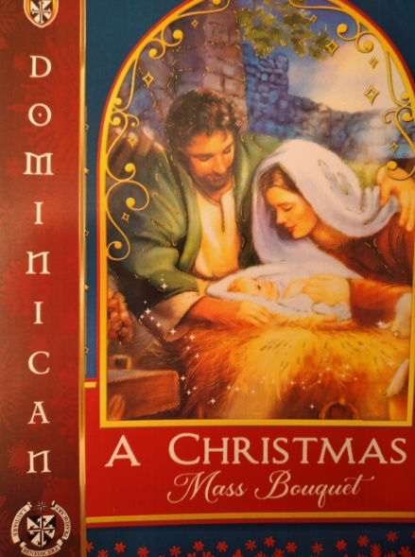

*Dominican Christmas Mass Bouquets are now available at Lectio Office.*

*The intentions will be remembered in a Novena of Masses during the Octave of Christmas.*

Lectina Divina

The Lectio communities will journey together in community with the Sunday Gospels for the Season of Advent week commencing 25th November.  The Advent booklets accompanying the series are now available in the Lectio office.

Upcoming dates:

Next Sunday - Feast of Christ the King

Sunday 1st Dec. 1st Sunday ofAdvent

Sunday 8th Dec. 2nd Sunday of Advent

Monday 9th Dec.

Feast of the Immaculate Conception *(Holyday of Obligation)*

Sunday 15th Dec. 3rd Sunday of Advent.

Church Statistics

In 2023, the number of Catholics in the world increased by 13.72 million. Only in Europe was there a decrease in the number of Catholics: down 474.000.