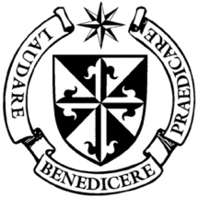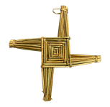

**Dominican Newsletter**

***St. Catherine’s Church, Dominic Street, Newry.***

**13th October 2024** Tel: 028 3026 2178 **28th Sunday - Year B**

***Rosary Sunday - also Prisoners’ Sunday***

**Masses:**  **Vigil:** Sat 7.30pm, **Sunday**: 8.00am, 9.30am, 11.00am, 12.30pm.

Weekdays: Monday to Saturday: 7.30 am, 11.00 am, 7.30 pm *(Vigil Sat.)*

Confession: Saturday: 11.30am - 12.30pm and 4.00pm – 5.00pm

**Website:** <https://newrydominican.com/> **Facebook**: [www.fb.com/newrydominican](http://www.fb.com/newrydominican)

**Watch live**: newrydominican.com/live **Lectio Centre**: lectio.newrydominican.com

BLESSING OF ROSES

TODAY



Those who have brought Roses will have them Blessed at Masses today *(incl. Vigil Mass)* and then take them home to be shared with others especially the elderly and the sick reminding them of the Rosary and Our Lady’s intercession. The Roses with their fragrance remind us of the beauty of the Rosary.

Tradition tells us that Our Lady appeared to St. Dominic and gave him the Rosary to be a strength in preaching the Gospel message.

**Relics of St. Bernadette**

**Newry Cathedral**

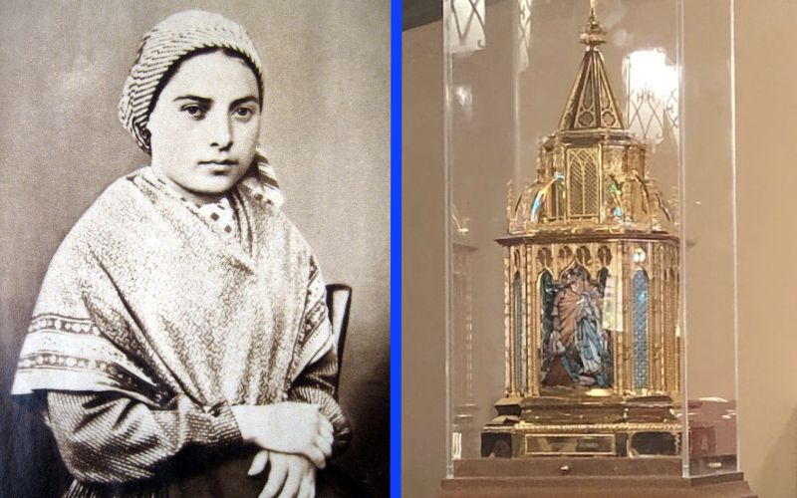

**THURSDAY 17th October**

**1.00pm** Relics welcomed

**Public Veneration**

Visits from School Groups

Confessions available .

**7.00pm** **Mass of Our Lady of Lourdes**

with Sacrament of the Sick.

**9.00pm**  Marian Vigil of Prayer

*Public veneration until 10.00pm*

**FRIDAY 18th October.**

**8.00am to 10.30am**

Veneration of Relics with Confessions

**10.30am** **Mass of St. Bernadette**

Veneration of Relics & Confessions

School Group visits.

**7.00 – 8.00pm** **Candlelight Procession**

8.00 – 10.00pm Veneration of Relics

*Visit of Relics ends & Cathedral closes.*

1

Streaming of the visit each day via www.newrycathedralparish.org.

**Relics of St. Bernadette**

*Petition slips will be available in the Cathedral for people to leave intentions which will be included in prayer during the visit. The petition slips will be brought back to Lourdes.*

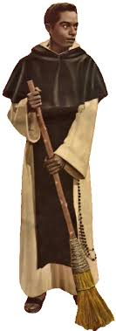

ST. MARTIN

NOVENA

3rd to 11th

November

Preacher

Fr. Tom McCarthy O.P

*(Galway)*

Weekdays

11.00 am & 7.30 pm

Sunday

12.30 pm & 7.30 pm

*St. Martin Candles and*

*St. Martin Religious objects*

*available in Lectio Centre.*

**Dominican Pilgrimage to**

**Knock Shrine**

*Takes place today with Archbishop Anthony Fisher, Dominican Archbishop of Sydney , Australia, as main celebrant.*

*The pilgrims from Newry will remember us in their prayers. We pray for their safe return.*

Pre – Baptism Meeting

The next Pre-Baptism Meeting  for parents and godparents takes place in Newry Parish Centre on Wednesday 16th of October at 7.30 p.m.

**Fr Timothy Radcliffe OP**

**to become a Cardinal**

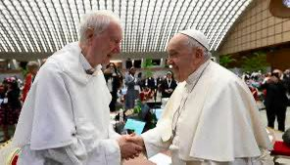

*Pope Francis has appointed 21 new Cardinals. The theologian, Dominican Father Timothy Radcliffe is one of the cardinal-elects named.*

***Fr Timothy Radcliffe,*** *born 22nd August 1945 served as Master of the Order of Preachers from 1992 to 2001. He is based in Oxford, England.*

*He led retreats for participants in the Synod on synodality in October 2023, and September 2024.*

Thank You!

*‘SONGS OF HOPE and REFLECTION’*

The Choir Studio, on 29th September

*A big thank you to Kathy Colgan and the Choir Studio, to the Lectio community members and to everyone who contributed in any way to make the Evening of Music, Hope and Reflection so special. An evening enjoyed by all.*

*£2,249.50 and €125 was raised on the evening. This will go towards the running costs of the Lectio Centre, Church and Priory.*

Lectio Centre: Open:Mon. to Sat. 10am – 5pm

*(closed for lunch 1 – 1.30pm*

Sunday 10.00am – 1.30pm

The collection for Sunday 6th of October

was £2,485. Thank you.

22nd of September was £2,505 *Thank you.*

*Thank you!*

Please feel free to take home copies of this Newsletter for others.