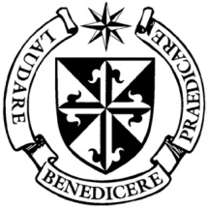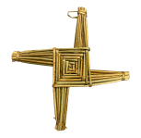

**Dominican Newsletter**

***St. Catherine’s Church, Dominic Street, Newry.***

**30th June 2024** Tel: 028 3026 2178 **11th Sunday Year B**

**Masses:**  **Vigil:** Sat 7.30pm, **Sunday**: 8.00am, 9.30am, 11.00am, 12.30pm.

Weekdays: Monday to Saturday: 7.30 am, 11.00 am, 7.30 pm *(Vigil Sat.)*

Confession: Saturday: 11.30am - 12.30pm and 4.00pm – 5.00pm

**Website:** <https://newrydominican.com/> **Facebook**: [www.fb.com/newrydominican](http://www.fb.com/newrydominican)

**Watch live**: newrydominican.com/live **Lectio Centre**: lectio.newrydominican.com

St. Oliver Plunkett

Oliver Plunkett was born on 1st November 1625, ordained a priest in 1654, deputed by the Irish bishops to act as their representative in Rome.

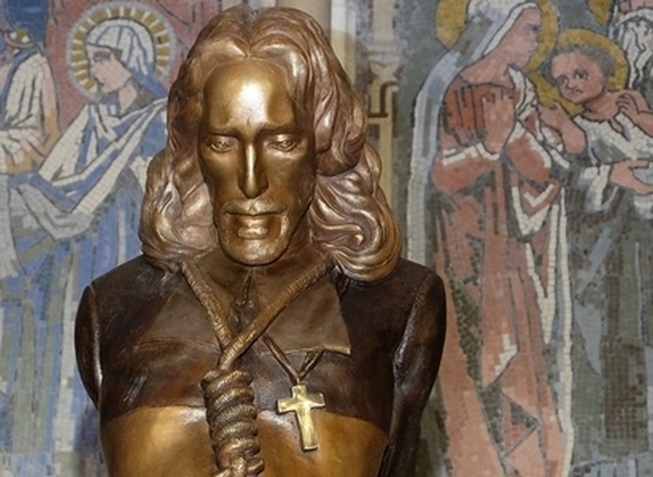

On 9 July 1669 he was appointed [Archbishop of Armagh](https://en.wikipedia.org/wiki/Archbishop_of_Armagh). In 1681 he was found guilty of high treason for promoting the Catholic faith and was condemned to death. Oliver Plunkett was [hanged, drawn and quartered](https://en.wikipedia.org/wiki/Hanged,_drawn_and_quartered) at [Tyburn](https://en.wikipedia.org/wiki/Tyburn,_London) on 1 July 1681 (aged 55), the last Catholic [martyr](https://en.wikipedia.org/wiki/Martyr) to die in England.

He was canonised in 1975, his head is on display in St. Peter’s Church in Drogheda.

Who Touched me? (Mark 5:21-43)

In today’s Gospel Jesus performs more miracles. He heals a sick woman and brings a child back to life. What brought about the cure in the woman was her faith. She believed if only she could touch the garment of jesus she would be healed. 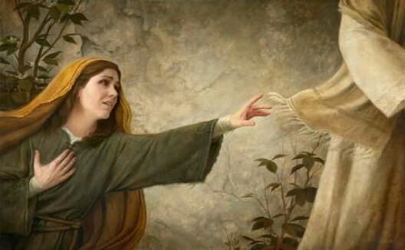

We too want to experience God’s healing and blessing. We too want to touch the hem of his garment. We reflect that in the way we like touch relics and statues, items of people we respected signs of our belief. We like to shake the hands of those who mean much to us.

*‘your faith has restored you to health; Go in peace and be free from your complaint.’*

Sacrament of the Sick

Monday 1st July 7.30pm Mass

***The Newsletter will take a summer break during July and August with just one addition appearing in August.***

**

'Give Reasons to Hope'

Statement on Westminster Elections by the Northern Catholic Bishops.

*Copies of this letter in which the Bishops give us thoughts before we vote are available at the back of the Church.*

*Please take one with you !*

Living the Word leaflet

Living the Word leaflet will finish for the summer break today and will resume in September.

We wish everyone a lovely summer.

Summer Break

Monday Morning Teas will finish for the summer tomorrow Monday 1st July and will recommence the first week in September.

We thank all who supported teh Monday Morning teas which were very much appreciated by those who attended.

Monday Charity Collection

The final collection for Women's Aid was on Monday 24th June, Eileen Murphy CEO and Helen Cranney, Support Services Manager thanked the congregations and were deeply appreciative of their generosity in support of the work of Women's Aid*.   Over the 6 month period £10,565 was  collected.*

For the next 6 months the Monday Collection will be for the Newry Gateway Club.

Visitors to Newry

*During the week we had a visit from two Dominicans from Cambridge, England, Fr. Gregory (Novice Master) and Bro. Dominic (Novice).*

Former Papal Secretary Archbishop Georg Gänswein (67), the longtime personal secretary to Pope Benedict XVI, and secretary Pope Francis has been named as the Vatican's ambassador to Lithuania, Estonia and Latvia

. 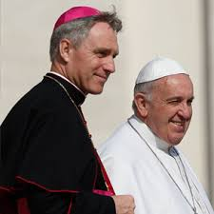

**Pope Francis to visit Belgium and Luxembourg**

*Pope Francis will make a three day visit to Belgium and Luxembourg (Brussels Leuven and Louvain-la-Neuve) from September(26th– 29th) after his trip to Asia.*

Words of Pope Francis

Highlighting the value of Lectio Divina, Pope Francis insisted that *“the quintessential spiritual reading of the Scripture is the community reading done in the liturgy, and in particular in the Holy Mass.”*

Pope Francis to Priests and Reigious:

*“May the chapel be the most frequented room in your religious houses, especially as a place of silence and quiet prayer.’*

The collection for Sunday 23rd of June £2,575. *Thank you!*

Please feel free to take home copies of this Newsletter for others.