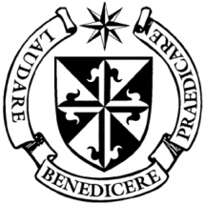

**Dominican Newsletter**

***St. Catherine’s Church, Dominic Street, Newry.***

**21st April 2024** Tel: 028 3026 2178 **VOCATIONS SUNDAY St. Brigid**

**Masses:**  **Vigil:** Sat 7.30pm, **Sunday**: 8.00am, 9.30am, 11.00am, 12.30pm.

Weekdays: Monday to Saturday: 7.30 am, 11.00 am, 7.30 pm *(Vigil Sat.)*

Confession: Saturday: 11.30am - 12.30pm and 4.00pm – 5.00pm

**Website:** <https://newrydominican.com/> **Facebook**: [www.fb.com/newrydominican](http://www.fb.com/newrydominican)

**Watch live**: newrydominican.com/live **Lectio Centre**: lectio.newrydominican.com

Pope Francis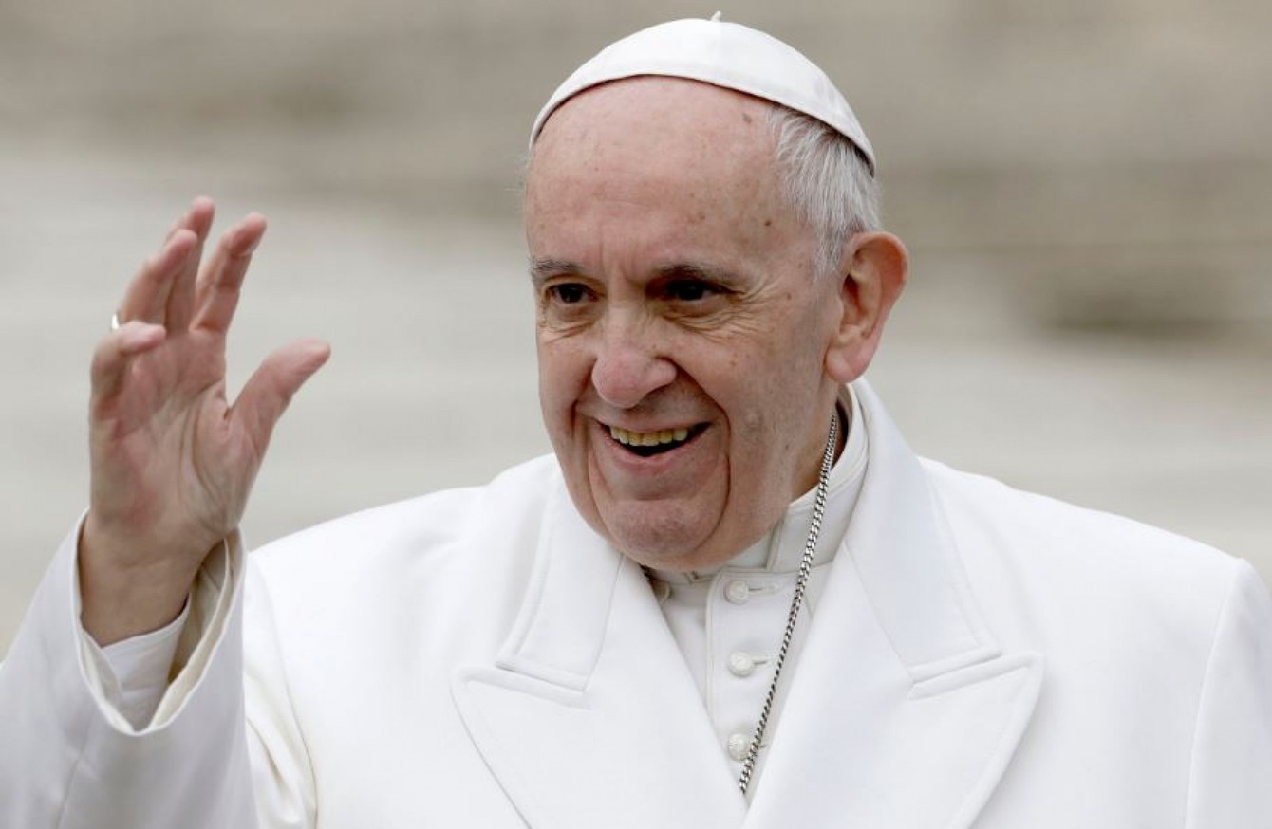

Pope Francis is to visit Indonesia, Papua New Guinea and Singapore from September 2nd to 13th the longest trip of Pope Francis’ papacy!

The Pope arrives in Indonesia on September 2nd and then travels to Papua New Guinea for 6th to 9th Sept. and east Timor from 9th to 11th Sept. concluding his visit to Singapore from 11th to 13th Sept.

The Catholic Church is the 3rd largest religious community in the country with 8.5 million members but are only 3% of the country’s total population.

**‘I am the Bread of Life,**

**whoever comes to me will never be hungry’** (John 10: 11-18)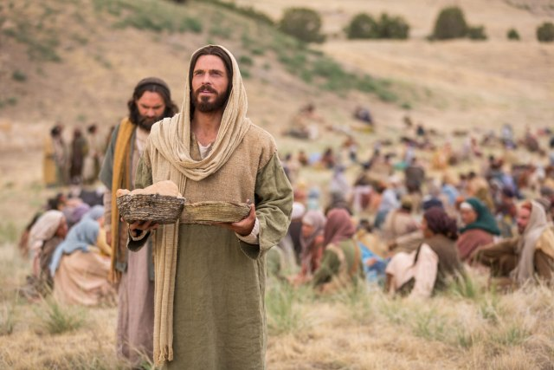

Jesus promises to be with those who come to him, they will have all they need from him. He does not want to lose us, but wants us to share with him in the Resurrection.

He is the one who feeds us, who nourushes us and who helps us to grow in faith. He calls out to us to hear his words and his promises. With the risen jesus we have nothing to lose but everything to gain.

*Today we welcome two of our Dominican Student brothers to Newry this weekend who will be present at Masses and asking us to encourage and pray for vocations.*

*We hope they will enjoy their visit with us.*

Handel’s Messiah

Last week Handles Messiah was performed in Dublin at DCU Theatre by Tallaght Choral Society as part of the celebrations of *Dominicans 800 years in Ireland*. It was attended by people with Dominican connections from all over Ireland and enjoyed by all.

Mass Cards available at Lectio Centre

**Ferrero Rocher Chocolates and Our Lady of Lourdes!**

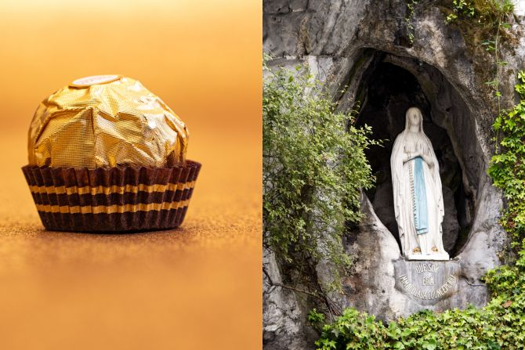

*Michele Ferrero, the company’s founder and a devout Catholic, had a deep devotion to the Blessed Virgin Mary and wanted to honor her through his work.*

*It is reported that he named his company* ***“Rocher****” after the****,*** *the* ***Rocher (the Rock) of Massabielle,*** *which marks the location where the Virgin Mary appeared to St. Bernadette in Lourdes, France.*

*At the 50th anniversary of the founding of the company, Ferrero said:* ***“The success of Ferrero we owe to Our Lady of Lourdes; without her we can do little’.***

Vatican Document

on Human Dignity

“DIGNITAS INFINITA”

*(Given in Rome, at the Dicastery for the Doctrine of the Faith, on 2 April 2024,*

In the coming weeks we will look at excerpts of the new Vatican Document “DIGNITAS INFINITA” dealing with many issues in society and the response of the Church.

The document begins by emphasising the theme of human dignity, the dignity of every person and addresses growing concerns such as ‘*gender theory,* *sex changes, surrogacy, euthanasia, abortion, poverty, human trafficking and war’.*

It states that Scripture teaches that all human beings possess inherent dignity because they are created in the image and likeness of God

*“God said, ‘Let us make humankind in our image, after our likeness’ […] So God created human beings in his own image, in the image of God he created them male and female”*

*(Gen. 1:26-27).*

*(to be continued)*

*The full document can be downloaded at*

*www.dignitas Infinita*

 Sacred Heart Grammar School

A Musical Evening

in St. Clare's Hall

Tuesday 30th April at 7.30pm.

*Proceeds in aid of the work of the Sisters of St Clare in Central America.*

Two New Priests Ordained

in Armagh Cathedral

Fr.Francesco Campiello

& Fr.Davis Haperkorn

*(from the seminary in Dundalk)*

were ordained Priests yesterday

by Archbishop Eamon Martin.

*May God’s blessing be upon them!*

Recently Deceased:We remember the repose of the soul of Margaret English *(formerly of Warrenpoint)*  whose funeral took place on Tuesday.

May she Rest in Peace

Collection for Sunday 14th April

was £2,732. *Thank you.*

*Please turn off your phone in the Church.*

Please feel free to take home copies of this Newsletter for others.