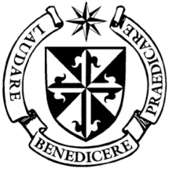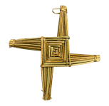

**Dominican Newsletter**

***St. Catherine’s Church, Dominic Street, Newry.***

**28th April 2024** Tel: 028 3026 2178 **5th Sunday of Easter** St. Brigid

**Masses:**  **Vigil:** Sat 7.30pm, **Sunday**: 8.00am, 9.30am, 11.00am, 12.30pm.

Weekdays: Monday to Saturday: 7.30 am, 11.00 am, 7.30 pm *(Vigil Sat.)*

Confession: Saturday: 11.30am - 12.30pm and 4.00pm – 5.00pm

**Website:** <https://newrydominican.com/> **Facebook**: [www.fb.com/newrydominican](http://www.fb.com/newrydominican)

**Watch live**: newrydominican.com/live **Lectio Centre**: lectio.newrydominican.com

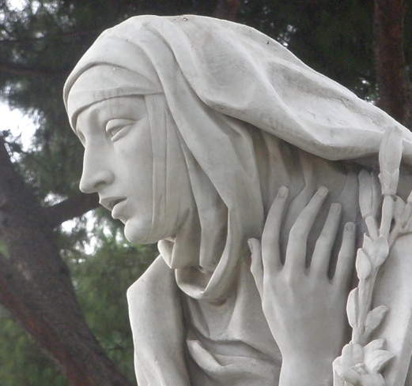

**St. Catherine**

**of Siena**

Feast Monday 29th April

St. Catherine of Siena was born during the outbreak of the plague in Siena in Italy on March 25, 1347. She was the 25th child born to her mother, Catherine herself was a twin, but her sister did not survive infancy. Later in life she joined the Dominican Third Order and spent her time in study and prayer. At 21 she had a mystical experience which she described as a ***‘mystical marriage to Christ’***.

She was very much involved with developments in the Church at the time. She influenced the Pope causing him to return to Rome at a time when the Church was divided. She was highly respected by popes and used to negotiate on the Pope’s behalf. She had a great love for the Church and worked strenuously for the defense of the Church.

*She died on April 29th 1380 at the age of 33.*

Siena Monastery Drogheda

The Dominican presence in Drogheda is at the *Monastery of Saint Catherine of Siena*

(The Twenties in Drogheda). Visitors are always welcome where the Sisters have exposition of the Blessed Sacrament all day in their chapel and pray for our intentions.

*‘Being nuns of the Order of Preachers means that we belong to the worldwide Dominican Family – Friars, Nuns, Sisters, Laity –The Nuns seek, ponder and call upon Him in solitude – so that the word proceeding from the mouth of God may not return to Him empty, but may accomplish those things for which it was sent’.*

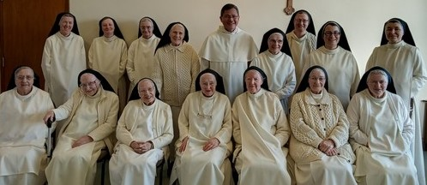

Dominican Nuns, Drogheda with Fr. Gerard Timoner O.P. Master of the Dominican Order.







Lectio Centre News

The Lectio communities will meet again to journey together with the Sunday Gospels for the Pentecost Series, week commencing Monday 6th May.

The series will run for 5 weeks.

The Lectio booklet which accompanies the series is now available

in the Lectio office.

Plant Sale outside the Church

on Sunday 12th May

*First Holy Communion Cards,*

*Confirmation Cards,*

*Missals, Bibles and Gift items*

Available at Lectio Centre Office

*Beside Church*

Many thanks,

Complimentary Tea/Coffee

and Refreshments

After 9.30am Sunday Mass

and after 11.00am Mass - Monday

in Dominican Hall beside Church

*All welcome!*

Drumalane Church

First Saturday Devotions- will take place in Church of the Assumption, Dromalane on *Saturday 4th May* with a period of meditation from 9.45-10.00am, followed by the Rosary 10am, Mass 10.30am and Sacrament of Reconciliation 11.00am.

**Pope Francis Visits Venice**

Today Pope Francis visits Venice on a one day trip. He will celebrate Mass in St. Mark’s Square and afterwards venerate the relics of St. Mark in the Basilica which were transported from Alexandria in Egypt.

He will also meet those in the Women’s Prison, meet with Artists and afterwards meet with Young people before returning to Rome.

**Saturday Meeting in Rome**

**“A Caress and a Smile”** is the name given to a gathering in the ***Vatican’s Paul VI Hall*** yesterday in Rome where 6,000 elderly people, grandparents, and grandchildren from Italy met Pope Francis.

Pope Francis has also established the ***World Day for Grandparents and the Elderly,*** which this year will be celebrated on July 28.

YOUTH 2000

Ulster Day Retreat

Saturday 4th May

*Ages 16 – 35 – Donation only.*

St. Paul’s Church

and Parish Hall

Falls Road Belfast

Starting 10.00am

[www.youth2000.ie](http://www.youth2000.ie) - also Facebook

Recently Deceased: We remember the repose of the soul of Eileen Torley from Raymond Kelly Park whose funeral took place on Monday.

May she Rest in Peace

Collection for Sunday 21st April

was £2,710 *Thank you!*

Please feel free to take home copies of this Newsletter and for others.