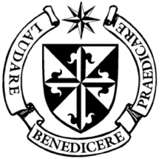

**Dominican Newsletter**

***St. Catherine’s Church, Dominic Street, Newry.***

**17th September 2023** Tel: 028 3026 2178 **24th Sunday - Year A**

**Masses:**  **Vigil:** Sat 7.30pm, **Sunday**: 8.00am, 9.30am, 11.00am, 12.30pm.

**Weekdays:** Monday to Saturday: 7.30 am, 11.00 am, 7.30 pm *(Vigil Sat.)*

**Confession: Saturday: 11.30am - 12.30pm and 4.00pm – 5.00pm**

**Website:** <https://newrydominican.com/> **Facebook**: [www.fb.com/newrydominican](http://www.fb.com/newrydominican)

**Watch live**: newrydominican.com/live **Lectio Centre**: lectio.newrydominican.com

**Pentecost**

**New Deacons:** **Three of our Dominican brothers were ordained deacons last weekend in Dublin by Bishop Denis Nulty.**

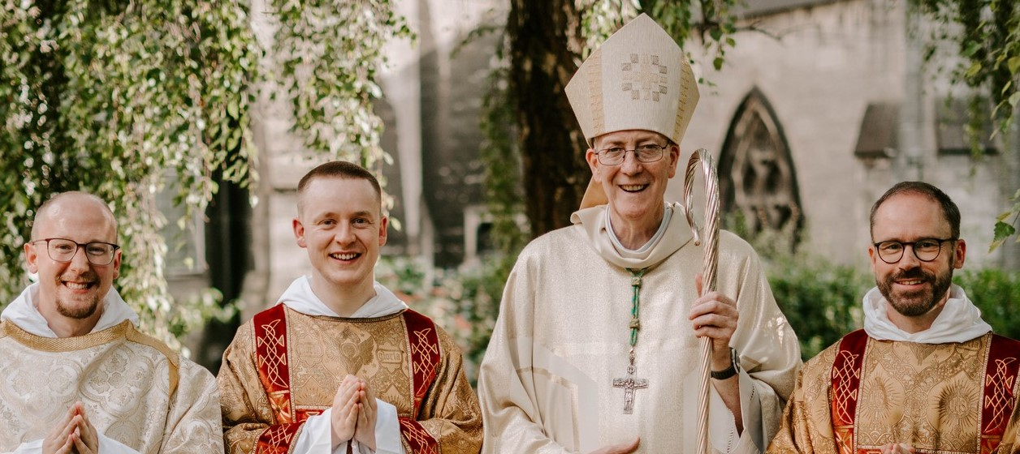

**Br Błażej Białek OP, Br Chris Gault OP, and Br Benedict McGlinchey OP,**

with Bishop Denis Nulty of Kildare and Leighlin, Photography: Br Sean Blackwell OP

.Last weekend was special with three of our students ordained deacons by Bishop Denis Nulty. We will have 17 Dominican Students studying in St. Saviours, Dublin in the coming year with thirteen from the Irish Dominican Province, two from Holy Rosary Province in Hong Kong (one Chinese and one Philipino), and two from the Polish Province. We also have two new novices in our Dominican Novicate in Cork who received the Dominican habit on Thursday.

**Next Sunday 23rd /24th September** we will be having the **Annual Collection for the Education of our Dominican Students.** Some of our Student brothers will be with us in Newry during that weekend and will speak at the weekend Masses.



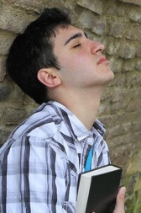

**FORGIVENESS:** (Matt. 18:21-35 today’s Gospel)

*When we talk about healing we often think of it as physical or mental healing but in today’s Gospel Jesus speaks about another kind of healing –* ***‘Forgiveness’****. It can be slow for hurt to heal. We remember the times when people hurt or offended us and it can be slow to let go of that hurt. Saying we are sorry and being able to forgive can bring great healing.*

**

**SMA Novena** in honour of

S**t. Therese of the Child Jesus**

Sat 23rd Sept. to Sun 1st Oct.

Daily Mass and Novena Prayers

**10am and 7.30pm**

**SMA Chapel Dromantine**

**QUIZ NIGHT:**  In the Bank Bar on Thursday 19th October. Proceeds in aid of Church, Priory and Lectio centre. Further details later.

**Br. Rudhaire Grieve O.P.** will be ordained priest here in our Church on ***Sunday 1st October at 3.00pm***.

**Parish Envelopes**

*Parish Envelopes put into the Offertory Collection do not go to the Dominican Church. We have to return parish envelopes to their respective parishes. St. Catherine’s Dominican is not a parish and does not have parish envelopes.*

*It is easier for us if parish envelopes do not end up in the Collection here in the Dominican. Keep for your own parish.*

**Tea/Coffee and Refreshments**

*After 9.30am Sunday Mass*

*and after Monday 11.00am Mass*

*In Dominican Hall beside Church.*

**LECTIO CENTRE:** Masses and Anniversaries can be booked at the lectio Office. Wide selection of Mass Bouquets available. Also St. Martin Magazine available.

**DOMINICAN PILGRIMAGE TO KNOCK**

**Sunday October 8th**

Contact: Freda McElroy Tel: 302 63 584.

**Questions and Answers .....**

***Why does the priest wash his hands at the end of the offertory in the Mass?***

Towards the end of the Offertory the priest washes his fingers and says: ***‘Wash me, O Lord,***

***from all my iniquity***

***and cleanse me from my sin’***

This gesture is a sign of the priest’s desire for purity of heart as he offers Mass. The washing of the hands is a physical and spiritual cleansing a sign of respect for the sacrament of the Eucharist.

**Rosminian Fathers - Gentili Sunday**

**Calvary Omeath.**

Sunday 24th September, Mass 3.00pm

*Fr. Oliver Stanfield (Celebrant)*

*Followed by the Blessing of the graves.*

. Everyone welcome.

**Pope Francis on drug addiction:**

on Sunday he said we are called to act like Jesus and cannot be indifferent to the situations that lead people, especially adolescents, into drug addiction.

***“Behind every addiction there are concrete experiences, stories of loneliness, inequality, exclusion, lack of integration,”*** *he said.* ***“Faced with these situations, we cannot be indifferent.”***

***“The Lord Jesus stopped, became close, and we too are called to bend down and bring back to life those who fall into the slavery of drugs and bring them back to life.***

**healed wounds.”**

**Last Sunday’s Offertory Collection**

**£ 2,617** *Thank you!*

*Feel free to take copies of this Newsletter home with you!*