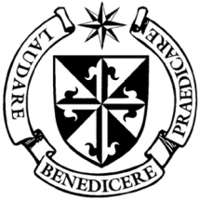
Dominican Newsletter
St. Catherine’s Church, Dominic Street, Newry.
28th May 2023 Tel: 028 3026 2178 PENTECOST
Masses: Vigil: Sat 7.30pm, Sunday: 8.00am, 9.30am, 11.00am, 12.30pm.
Weekdays: Monday to Saturday: 7.30 am, 11.00 am, 7.30 pm (Vigil Sat.)
Confession: Saturday: 11.30am - 12.30pm and 4.00pm – 5.00pm
Website: https://newrydominican.com/ Facebook: www.fb.com/newrydominican
Watch live: newrydominican.com/live Lectio Centre: lectio.newrydominican.com

Pentecost
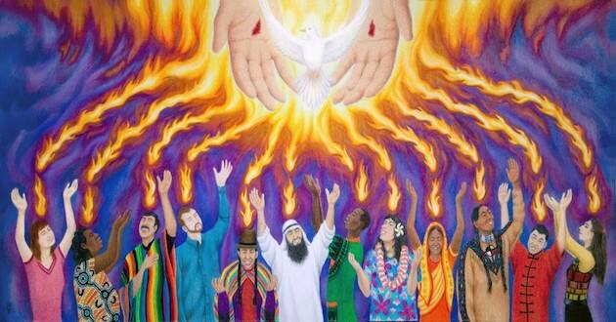

Pentecost brings us to the end of the Easter season. Christ has ascended and the Holy Spirit comes to us. The Holy Spirit fills us with the power of God and reminds us of God’s presence. We saw how the Holy Spirit came upon the Virgil Mary (‘she conceived by the Holy Spirit’) and she gave birth to Jesus Christ. The Holy Spirit was with Jesus in his ministry and it was the Holy Spirit who caused him to rise from the dead. The love of God is manifest in the Holy Spirit and fills us with God’s love. Let us always be aware of the Holy Spirit especially at the times we feel alone and in difficulty. May we be encouraged by the words of Pope Francis:

"No matter how difficult the situation may be we must not give up and we must not forsake pursuing what is essential in our Christian life, namely evangelization," Let us prepare to receive the Holy Spirit this coming Pentecost, asking for that grace, to evangelize, to always carry forward the message of Jesus." Pope Francis
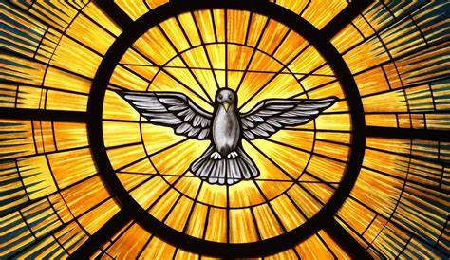

St. Vincent de Paul Society
Church Door Collection after Sunday Masses. The SVDP are very thankful for the support they receive outside our Church after Masses.
Pope Francis to attend World Youth Day and visit Fatima

The Vatican announced that Pope Francis will travel to Lisbon, Portugal, for World Youth Day August 2nd to 6th, and with a visit to the Shrine of Our Lady of Fatima on August 5th.

Pilgrimage to
San Giovanni Rotondo
6 days Incl: Pietrelcina
(Birthplace of Padre Pio)
Dept. 3rd Oct. (ex. Dublin) £770
Contact Anita: 077 697 44 836
Limited places, early booking advised

GUIDED TOURS OF NEWRY CATHEDRAL
Guided tours of the Cathedral will be offered on the following dates:
Wed. 14th June 7pm
Wed. 5th July 2pm
Wed 19th July 7pm
Wed 16th August 2pm
Wed 30th August 7pm
Each tour - approximately 90 minutes.
There is no charge for these tours.

Receiving Holy Communion
The preferred option of receiving Holy Communion in the hand continues in our Church. Anyone who needs to receive on the tongue can go to St. Joseph’s altar towards the end of Communion.

Lectio Centre: Mass Anniversaries and Intentions can be booked through the Lectio Office. A variety of Mass Cards and the St. Martin Magazine are available at the Centre.
.

BAPTISMS: Parents, please make sure that you call to the Priory to confirm your child’s baptism with one of the priests. This includes a baptism that has been scheduled.

Feasts this week ........
Monday 29th The Blessed Virgin Mary
Mother of the Church.
Wednesday 31st The Visitation
Thursday 1st St. Justin
Friday 2nd First Friday
Saturday 3rd Saint Kevin
Sunday 4th Trinity Sunday

Last Week’s Offertory Collection
£ 2,305.
Thank you for your support.
Thank you!

Live Streaming from Church
We have been online from the Church 24 hours a day. Many have found it helpful to be able to see the Church and services 24hours a day.
Because of new restrictions with GDPR we soon will be able now to have live streaming only for Masses and other services.
Feel free to take copies of this Newsletter for others and those at home.

