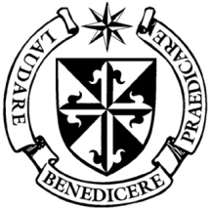
Dominican Newsletter
St. Catherine’s Church, Dominic Street, Newry.
January 29th 2023 4th Sunday of the (Year A) Tel: 028 3026 2178
Masses: Vigil: Sat 7.30pm, Sunday: 8.00am, 9.30am, 11.00am, 12.30pm.
Weekdays: Monday to Saurday: 7.30 am, 11.00 am, 7.30 pm (Vigil on Sat.)
Confession: Saturday: 11.30am - 12.30pm and 4.00pm – 5.00pm
Website: https://newrydominican.com/ Facebook: www.fb.com/newrydominican
Watch live: newrydominican.com/live Lectio Centre: lectio.newrydominican.com

‘BLESSED’
Pope asks Fr Timothy Radcliffe
to lead bishops' Synod Retreat

Pope Francis has asked Fr. Timothy Radcliffe, an English Dominican, to lead the retreat for bishops and participants taking part in the Synod in October.
The former Master of the Order of Preachers (Dominicans) will lead the prayer gathering from 1st to 3rd October 2023 as preparation for those attending the Synod of Bishops Assembly in the Vatican.

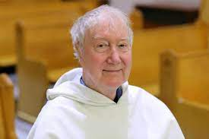

The words ‘Blessed’ or ‘Happy’ appear in
today’s Gospel. Being blessed leads us to
happiness. When we are blessed God’s grace grace is bestowed upon us. Jesus brings
the disciples to Mt. Tabor and tells them
how blessed they are as his disciples.
The blessings God gives us can lead us to
‘Happiness in the Lord’.
FEAST OF ST. BLAISE (Friday 3rd)
Feast of the Presentation
Thursday 2nd February
‘CANDLEMAS DAY’
Bring your candles to the Church on this Day to have them blessed.

Simeon reveals the Child Jesus
‘as a light to reveal God
to the nations’

A general Blessing of
Throats is given at the
end of Masses on
Friday.
Because of the risk
of the virus being
Monday Morning
Tea/Coffee and Chat
In Dominican Hall
after 11.00am Mass. All Welcome!

passed on with candles
touching throats we
are unable to have
individual Blessings of
throats.
Pope Francis’ words last Sunday
‘Word of God Sunday’

“This is our mission: to become seekers of the lost, oppressed, and discouraged, not to bring them ‘ourselves’ but the consolation of the ‘Word’, the disruptive proclamation of God that transforms life, to bring the joy of knowing that he is our Father and addresses each one of us, to bring the beauty of saying:
‘Brother, sister, God has come close to you,
listen and you will find in his Word an amazing gift!’

Journeying with the Word of God in Lent
The Lenten series of Lectio Divina for Newcomers presented by Fr Joseph Ralph OP begins
(In Person) Monday 20th February at 7pm or
(Online) Thursday 23rd February at 8pm
and continues for six weeks.
For further information and to book a place,
please contact the Lectio Centre, Newry with preferred option. (Numbers are limited)
Tel: 028 302 62178 (Mon-Sat 10-5pm)
Email: lectiocentre35@gmail.com
Further resources:- lectio.newrydominican.com

Feasts during the week
Monday 30th St. Aidan
Tuesday 31st St. John Bosco (Salesians)
Wednesday 1st Feb. St. Brigid of Faughart
Thursday 2nd The Presentation of the Lord
Friday 3rd St. Blaise with a general
Blessing of Throats at Masses.

FREE CAR PARKING
available in the Butte rcrane Centre on Sundays until 1.30pm.
St. Brigid’s Crosses
on sale outside the Church
this weekend after Masses.

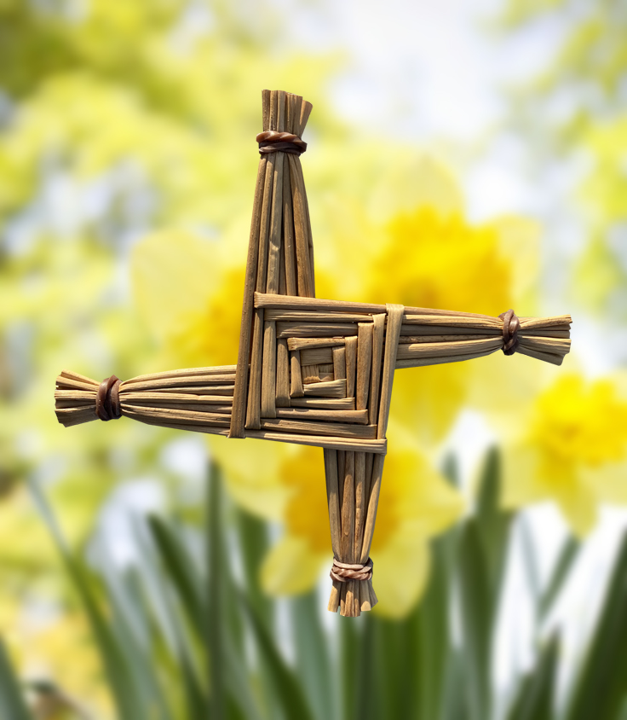

Thanks to our great team of volunteers
who collected rushes and made
the St. Brigid’s Crosses.

Receiving Holy Communion
The preferred option of receiving Holy Communion in the hand continues in our Church. Our priority is to keep people safe and protect them from getting the virus which is still around but not as dangerous. Anyone who wants to receive on the tongue can go towards the end of Communion to St. Joseph’s altar and the Priest/Eucharistic minister there will give you Communion there while following the normal sanitisation procedures.

Last Sunday’s Collection:
came to £2,482.
for which we thank you.

Pope Francis will visit the African countries of Congo and South Sudan from Jan. 31– Feb. 5.

Feel free to take copies of the Newsletter for others, those living alone and the elderly.

