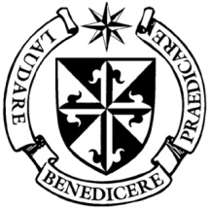
Dominican Newsletter
St St. Catherine’s Church, Dominic Street, Newry.
January 24th 2021 Tel: 028 3026 2178 - 3rd Sunday Year B
Website: https://newrydominican.com/ Facebook: www.fb.com/newrydominican
Watch live: newrydominican.com/live Lectio Centre: lectio.newrydominican.com

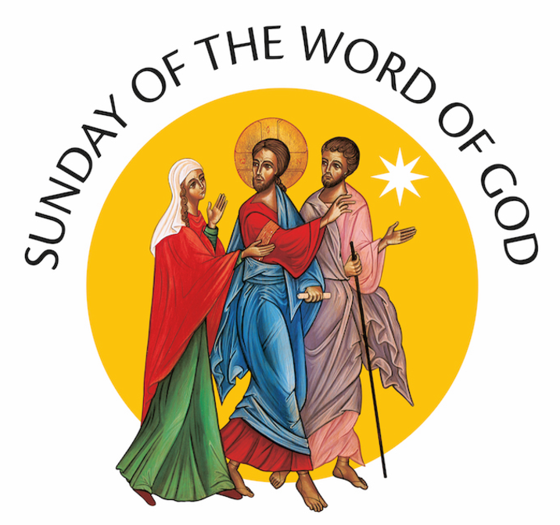

The image above for Word of God Sunday is of Jesus walking on the Road to Emmaus
with two disciples explaining to them the Word of God.’

Sunday 24th January
Pope Francis declares that “the Third Sunday in Ordinary Time is to be devoted to the celebration, study and dissemination of the Word of God”.
‘The Bible is not meant for a privileged few’, continues Pope Francis. It belongs “to those called to hear its message and to recognize themselves in its words”. The Bible cannot be monopolized or restricted to select groups either, he writes, because it is “the book of the Lord’s people, who, in listening to it, move from dispersion and division towards unity”.
Pope Francis invites local communities to find ways to “mark this Sunday with a certain solemnity”. He suggests that the sacred text be enthroned “in order to focus the attention of the assembly on the normative value of God’s Word”.
Here at the Dominican Priory the Lectio Centre is devoted to the Word of God and in line with the emphasis Pope Francis’ puts on the Word of God & Scripture.
Thanks to those who have sent in, or left donations at the hall door towards the Church and Priory. Your help is very much appreciated. It is impossible to thank you individually but we will remember you in our Masses. Thank you.

Feasts this Week
Monday 25th Conversion of St. Paul
Tuesday 26th Saints Timothy and Titus
Wednesday 27th St. Angela Merici
(Foundress of the Ursline Sisters)
Thursday 28th St. Thomas Aquinas O.P.
Saturday 30th St. Aidan. B. 550 in Cavan and founded a monastery in Ferns – Wexford.
The Lectio Centre is closed during the time of Covid Restrictions.
For Mass bookings contact the Lectio Centre by phone
Monday to Saturday between 10.00am to 5.00pm:

Telephone: 02830262178
Email at: lectiocentre@gmail.com

The Church is closed to the public for Masses
(with exceptions for Baptisms, Weddings & Funerals)
The Church will be open daily for private prayer from 12noon to 6.00pm Mo. – Sa.
and 2 – 6pm on Sundays.
Masses as usual are available online at
https://newrydominican.com/live/
The Church Webcam is online 24 hours a day.

Mass Weekdays (online): 7.30am, 11.00am & 7.30pm.
Sundays (online): (Sat. Vigil 7.30pm), 8.00am, 9.30am, 11.00am & 12.30pm

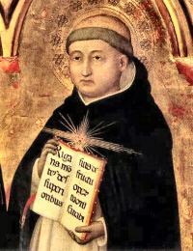
St. Thomas Aquinas O.P.
Feast Thursday 28th January.

Thomas was born in 1225 in Italy near the great Benedictine abbey of Montecassino, midway between Rome and Naples. He joined the Dominicans and went to study in Paris and then at Cologne with Albert the Great. He became a teacher in Paris and Rome and Naples. He was regarded as one of the most influential thinkers of medieval Scholasticism. An authority of the Roman Catholic Church and a prolific writer, Aquinas died on March 7th 1274. St. Thomas’s writings are widely studied today and his teachings are held in high regard. St. Thomas Aquinas is the patron saint of Universities Schools and Colleges. He is one of the great saints of the Dominican Order.
**************************************************************************
We remember all those who have died from the virus, especially those from in and around Newry.
In the past week ten Catholic Bishops around the world have also died of Covid 19 virus.

