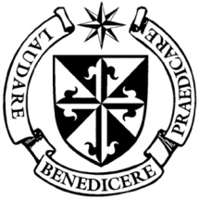
Dominican Newsletter
St St. Catherine’s Church, Dominic Street, Newry.
November 22nd 2020 Tel: 028 3026 2178 - CHRIST THE KING
Website: https://newrydominican.com/ Facebook: www.fb.com/newrydominican
Watch live: newrydominican.com/live Lectio Centre: lectio.newrydominican.com

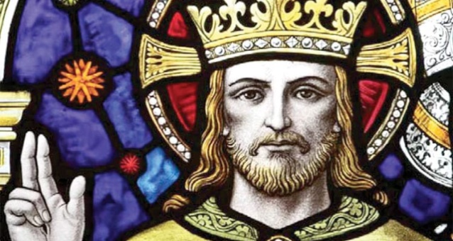
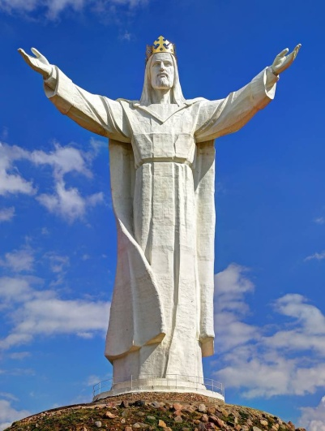

Christ the King
All over the world are statues and images of Christ the King - King of all creation, King in glory, King of eaven and earth, he is King over all.
Tallest Statue in the world of Christ the King is in Poland at 600 ft.
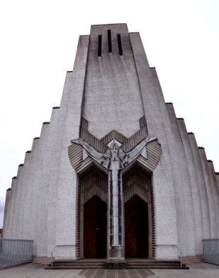
This Sunday, at the end of Church’s liturgical year, the Readings describe the enthronement of the victorious Christ as King in Heaven in all His glory. In 1925, in Instituting this Feast of Christ the King. Pope Pius XI proclaimed: “Pax Christi in regno Christi” (the Peace of Christ in the Reign of Christ). We honour Christ not just as King but ‘….. as a Servant King’:
‘The Son of Man did not come to be served, but to serve, and to give his life as a ransom for many.” Christ is our Servant King.
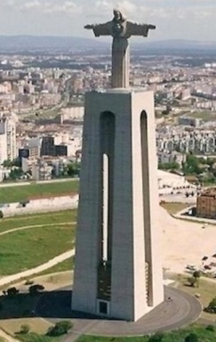
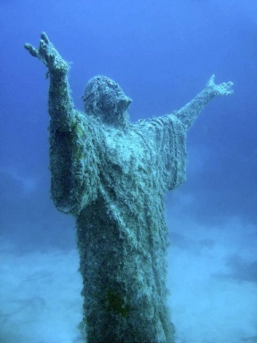
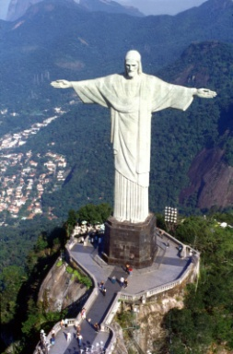

Rio de Janeiro Christ the King Cork Christ the King under the Sea Lisbon/Portugal
ACT OF SPIRITUAL COMMUNION
My Jesus, I believe that you are present in the Most Holy Sacrament.
I love You above all things, and I desire to receive You into my soul.
Since I cannot at this moment receive you sacramentally, come at least spiritually into my heart. I embrace you as if you were already there and unite myself wholly to you. Never permit me to be separated from you. Amen

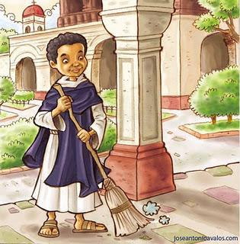
ST. MARTIN NOVENA
Thanks to all who joined us online and supported the
St. Martin Novena. It has been a difficult year not being able to have the Church open for the Novena and only having it online. The response was very good and many people told us how pleased they were. People watched the Novena from all over Ireland and abroad. Thanks also to those who helped us prepare for the Novena this year, as there was much work behind the scenes. THANK YOU TO ALL !

CHRISTMAS BAZZAR with a difference! Due to the current pandemic, the Christmas Bazaar will take a new format this year. In order to maintain safety protocols, all items can be pre ordered and picked up in the Dominican Hall at a pre arranged date and time.
Items Available : 1. Festive Foods and Gift Hampers at various prices. 2. Home Bakery Decorated Christmas Cakes, Mince Pies, Shortbread etc. Handmade Christmas Garlands, Christmas Log Centrepieces, Christmas wreaths and planters suitable for indoor, outdoor or for graves.
It is advisable to place orders early as items are limited.
To place Orders: Phone 07936516133. More details on Dominican Facebook page.
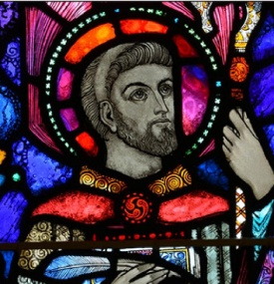
Saint Vincent de Paul Christmas Gifts
Because of the pandemic this Christmas we can only accept GIFT VOUCHERS as Christmas Gifts Please leave at Reception or in Collection Basket at Mass.

HOLY COMMUNION: is available at the Church between 4.00pm and 6.00pm on Sundays. For those confined to car and not able to walk please park car in front of the Church and a minister or priest will come and give communion at the car.

St. Columban
Lectio Centre Open for Mass Bookings,
Monday to Satuday: 10.00am to 5.00pm Sunday: 10am – 1.30pm
The Come to the Banquet leaflet reflecting on the Sunday gospel is available at the back of the church. Anyone wishing to receive it digitally can email the Lectio Centre on lectiocentre35@gmail.com

ADVENT SERIES ON LECTIO CIVINA
The Lectio Communities will reconvene for the season of advent – week commencing 23rd Nov.
Due to the current restrictions the communities will meet via Zoom.
The series will run for the 4 weeks of Advent.
Lectio Booklets for the series are available from the Lectio Centre.
Also , Dominican Christmas Mass Bouquets, candles and gifts are available online and from the Lectio Centre

St. Columban. Educated in Bangor,
Co. Down, he left Ireland in 590 and began
evangelizing setting up monasteries around
Europe. He died in 615.
DEPARTMENT OF HEALTH
have announced the
CLOSURE OF PLACES OR WORSHIP
except for weddings, and funerals.

From Friday 27th November (2 weeks),
(with a 25 max only allowed for
weddings and funerals)

Feasts this Week
Mon. 23rd St. Columban
Tue 24th Vietnamese Martyrs
Wed. 25th St. Clement of Rome
St. Coleman Born in 530 in West Cork
Fri 27th. St. Fergal, Born in Ireland. Became Bishop of Salsburg in 754.

Lectio Centre Open for Mass Bookings,
Monday to Satuday: 10.00am to 5.00pm Sunday: 10am – 1.30pm
The Come to the Banquet leaflet reflecting on the Sunday gospel is available at the back of the church. Anyone wishing to receive it digitally can email the Lectio Centre on lectiocentre35@gmail.com
ADVENT SERIES ON LECTIO CIVINA
The Lectio Communities will reconvene for the season of advent – week commencing 23rd Nov.
Due to the current restrictions the communities will meet via Zoom.
The series will run for the 4 weeks of Advent.
Lectio Booklets for the series are available from the Lectio Centre.
Also , Dominican Christmas Mass Bouquets, candles and gifts are available online and from the Lectio Centre

